

Timesheets

The big idea behind Timesheets is that Session Logs can drive Timesheets. This means that the instructor only needs to post a Session Log and a timesheet will automatically be created.

[ Click here to view a training video on Timesheet setup.](https://zoom.us/recording/share/nRim9h1SD5SlikK7mNlmJGXcUNDypb5VtIersixILdawIumekTziMw?startTime=1562716312000)

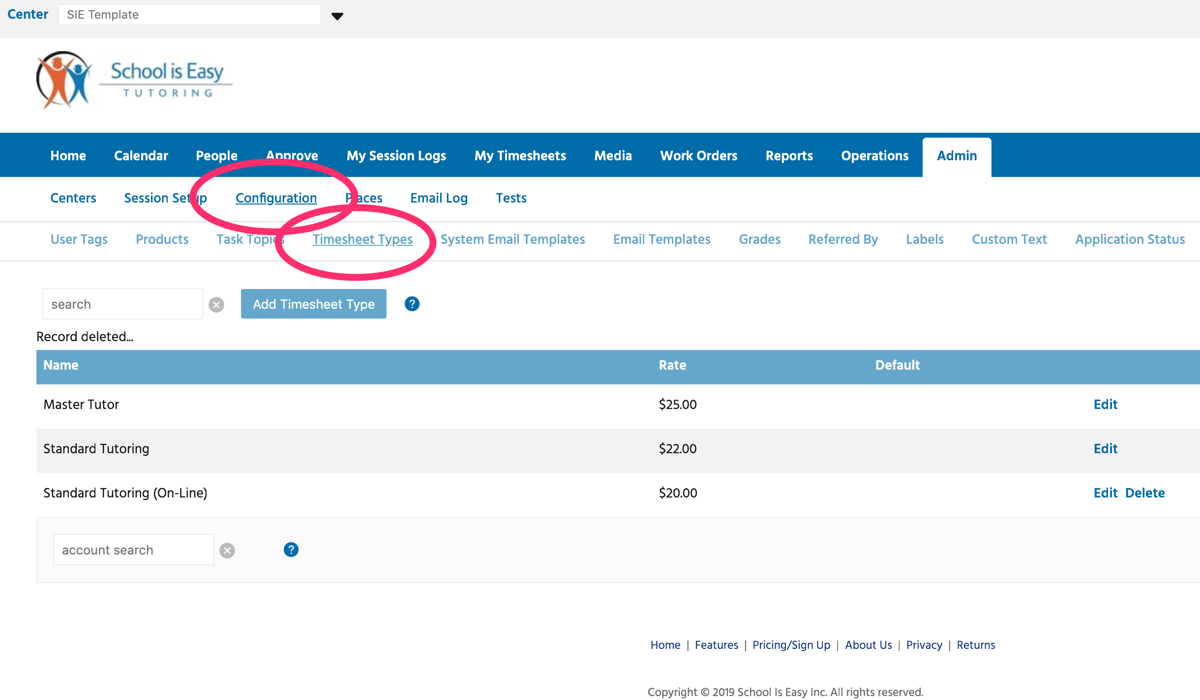

Timesheet Types are the pay rates you setup to pay your instructors and administrators.

To create or edit a Timesheet Type, go to Admin / Configuration / Timesheet Types. Here you will see a list of Timesheet Types and a Default Pay Rate. This rate can be overridden by a specific rate for individual tutors. We’ll look at that later.

To add a new Timesheet Type click on Add Timesheet Type

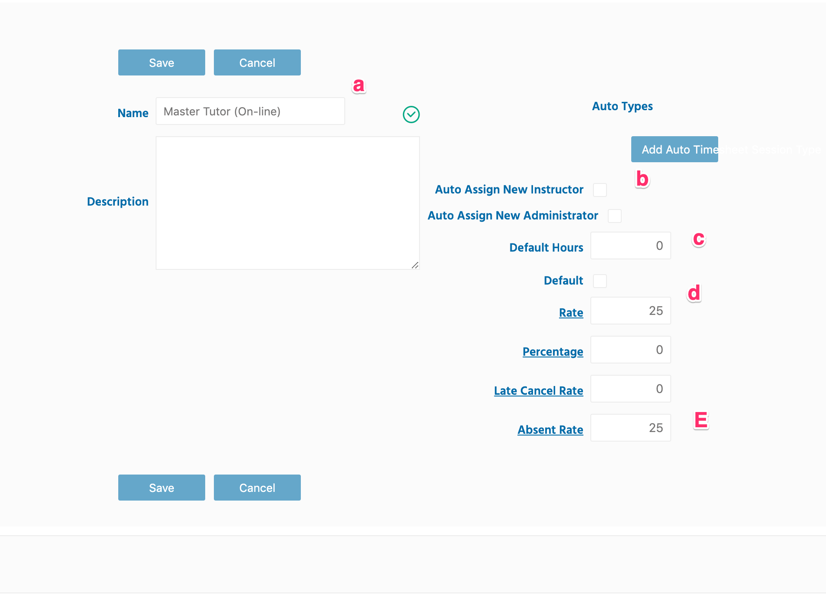

1. Enter a name.
2. Auto Assign New Instructor: if checked, this Timesheet Type will automatically be added to new instructor’s accounts when created.
3. This is the default duration for a Timesheet entry. This will not apply for instructors pay as their duration will match the Session Log they create for the student. You can leave this as 0 or enter 1hr. Again, it will be overridden if the session is longer or shorter than an hour.
4. Enter the default rate for this Timesheet. Know that you can create an override rate for individual instructors. (Ex: you want to pay a given instructor $.50 more per hour. You would set that up under the instructor’s account. We will look at that later.)
5. Do you want to pay the instructor for Late Cancelled and/or Absent students? Enter the amount here.

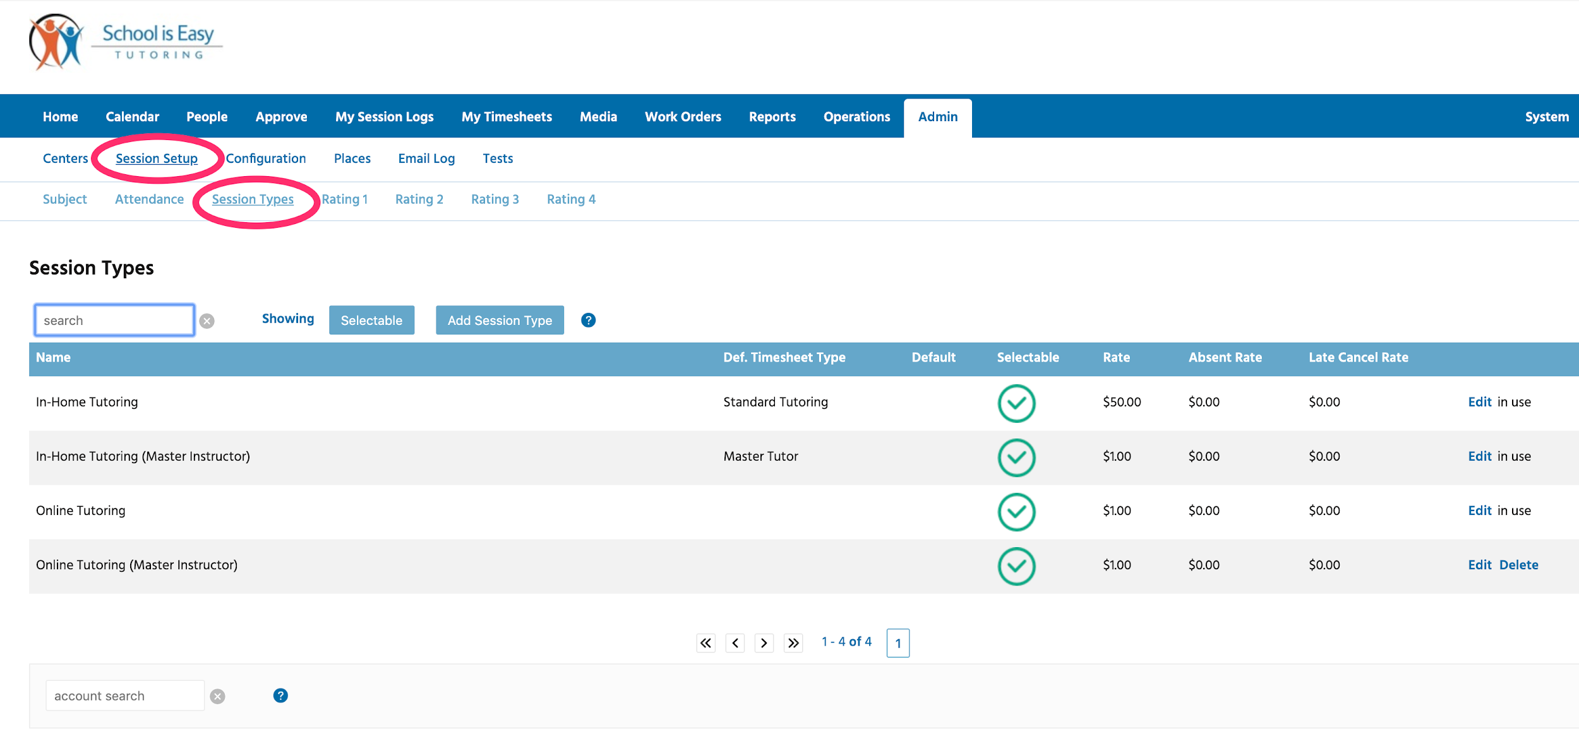

Now let’s look at Session Types under the Admin tab. Here we can see a list of Session Types. Session Types are the billable services you provide to your customers. They have a name and a default rate associated. Know that you can override this rate under the students account if you want to charge an individual student a different rate.

Also notest the Def. Timesheet Type column. This specifies what Timesheet should be used when a given Session Type is included in a Session Log. Above we see that the Session Type “In-Home Tutoring” creates a default Timesheet Type “Standard Tutoring”.

Click Add Session Type to Create a new Session Type.

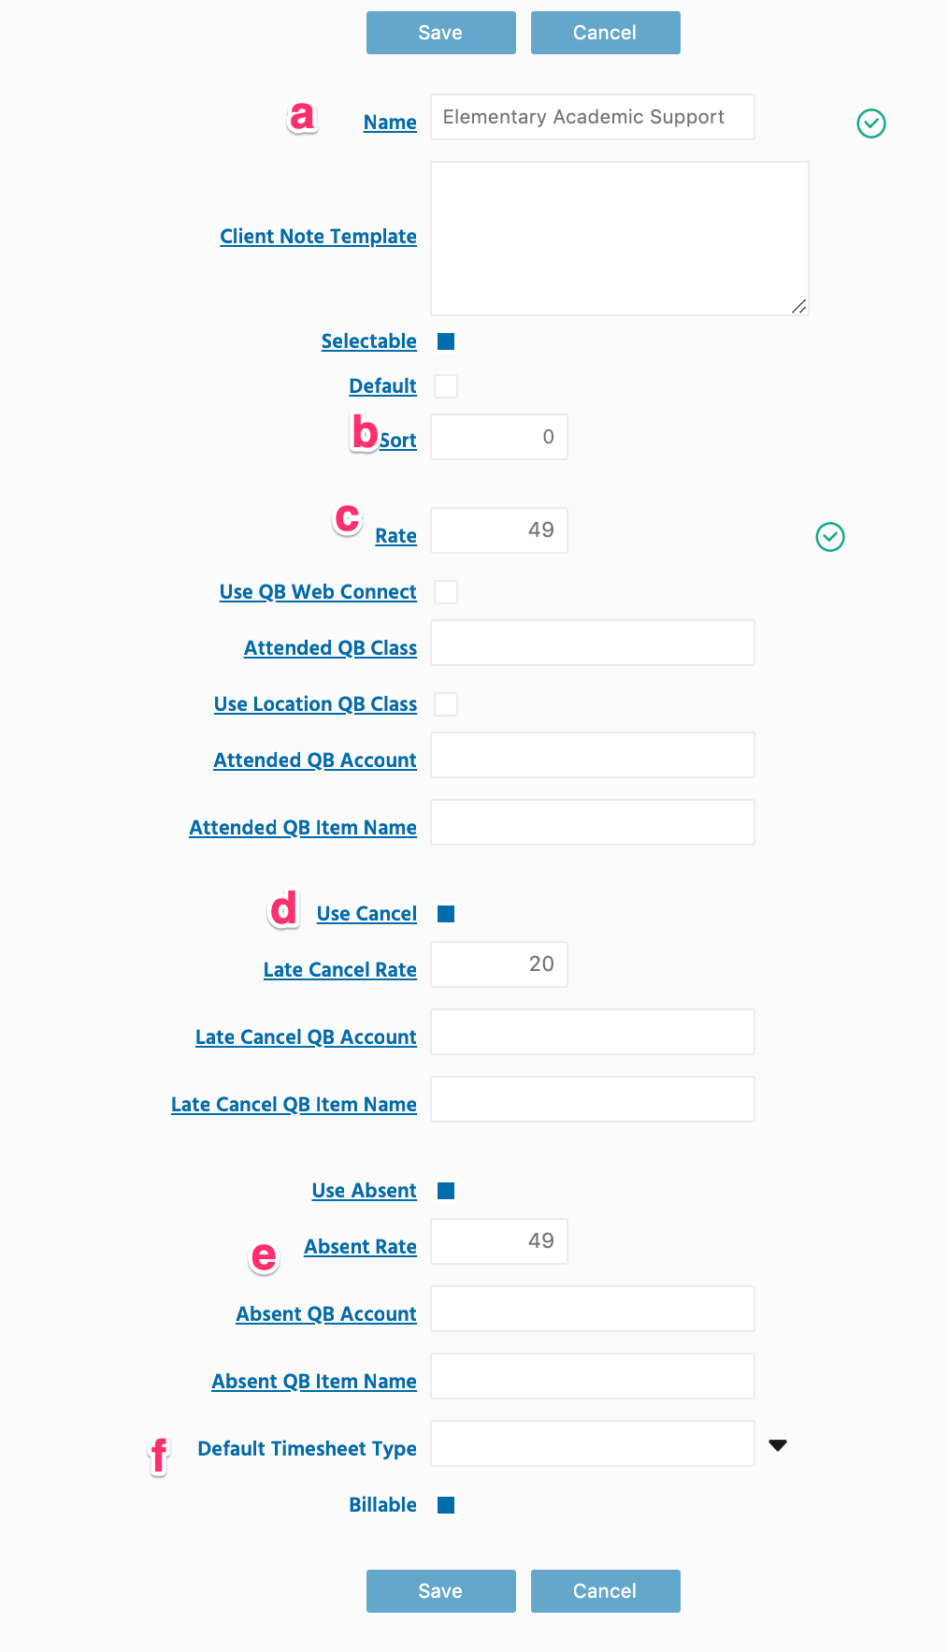

Previous page screenshot.

1. Name the Session Type. Keep it simple. Make it descriptive. Parents will see this Session Type name on their student’s Session Logs.
2. Sort - use this to sort the order that the Session Types appear in the lists.
3. Rate - define the default rate. Remember that you can override this rate under the student’s account, subtab Session Types.
4. Decide if you want to charge for Late Cancel and/or Absent
5. Same as d.
6. Add a default Timesheet Type. If you always want to pay instructors a given Timesheet Type when they log a particular Session Type, then add it here.

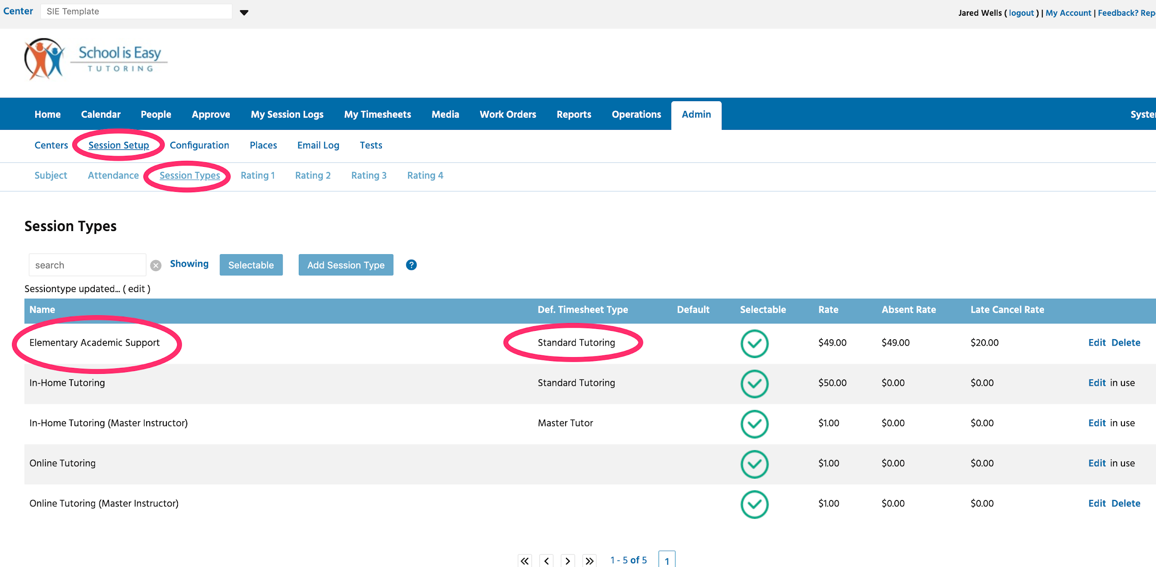

Now you can see that Session Type, “Elementary Academic Support”, has a default Timesheet Type, “Standard Tutoring”. Every time an instructor creates a session log with the Session Type, “Elementary Academic Support” session log, they will receive a timesheet entry using the Timesheet Type, “Standard Tutoring”. One thing to note, if the instructor has a Timesheet Type under their account with a different override rate, this override rate will be used. We’ll see how to add Timesheet Types to instructor account next.

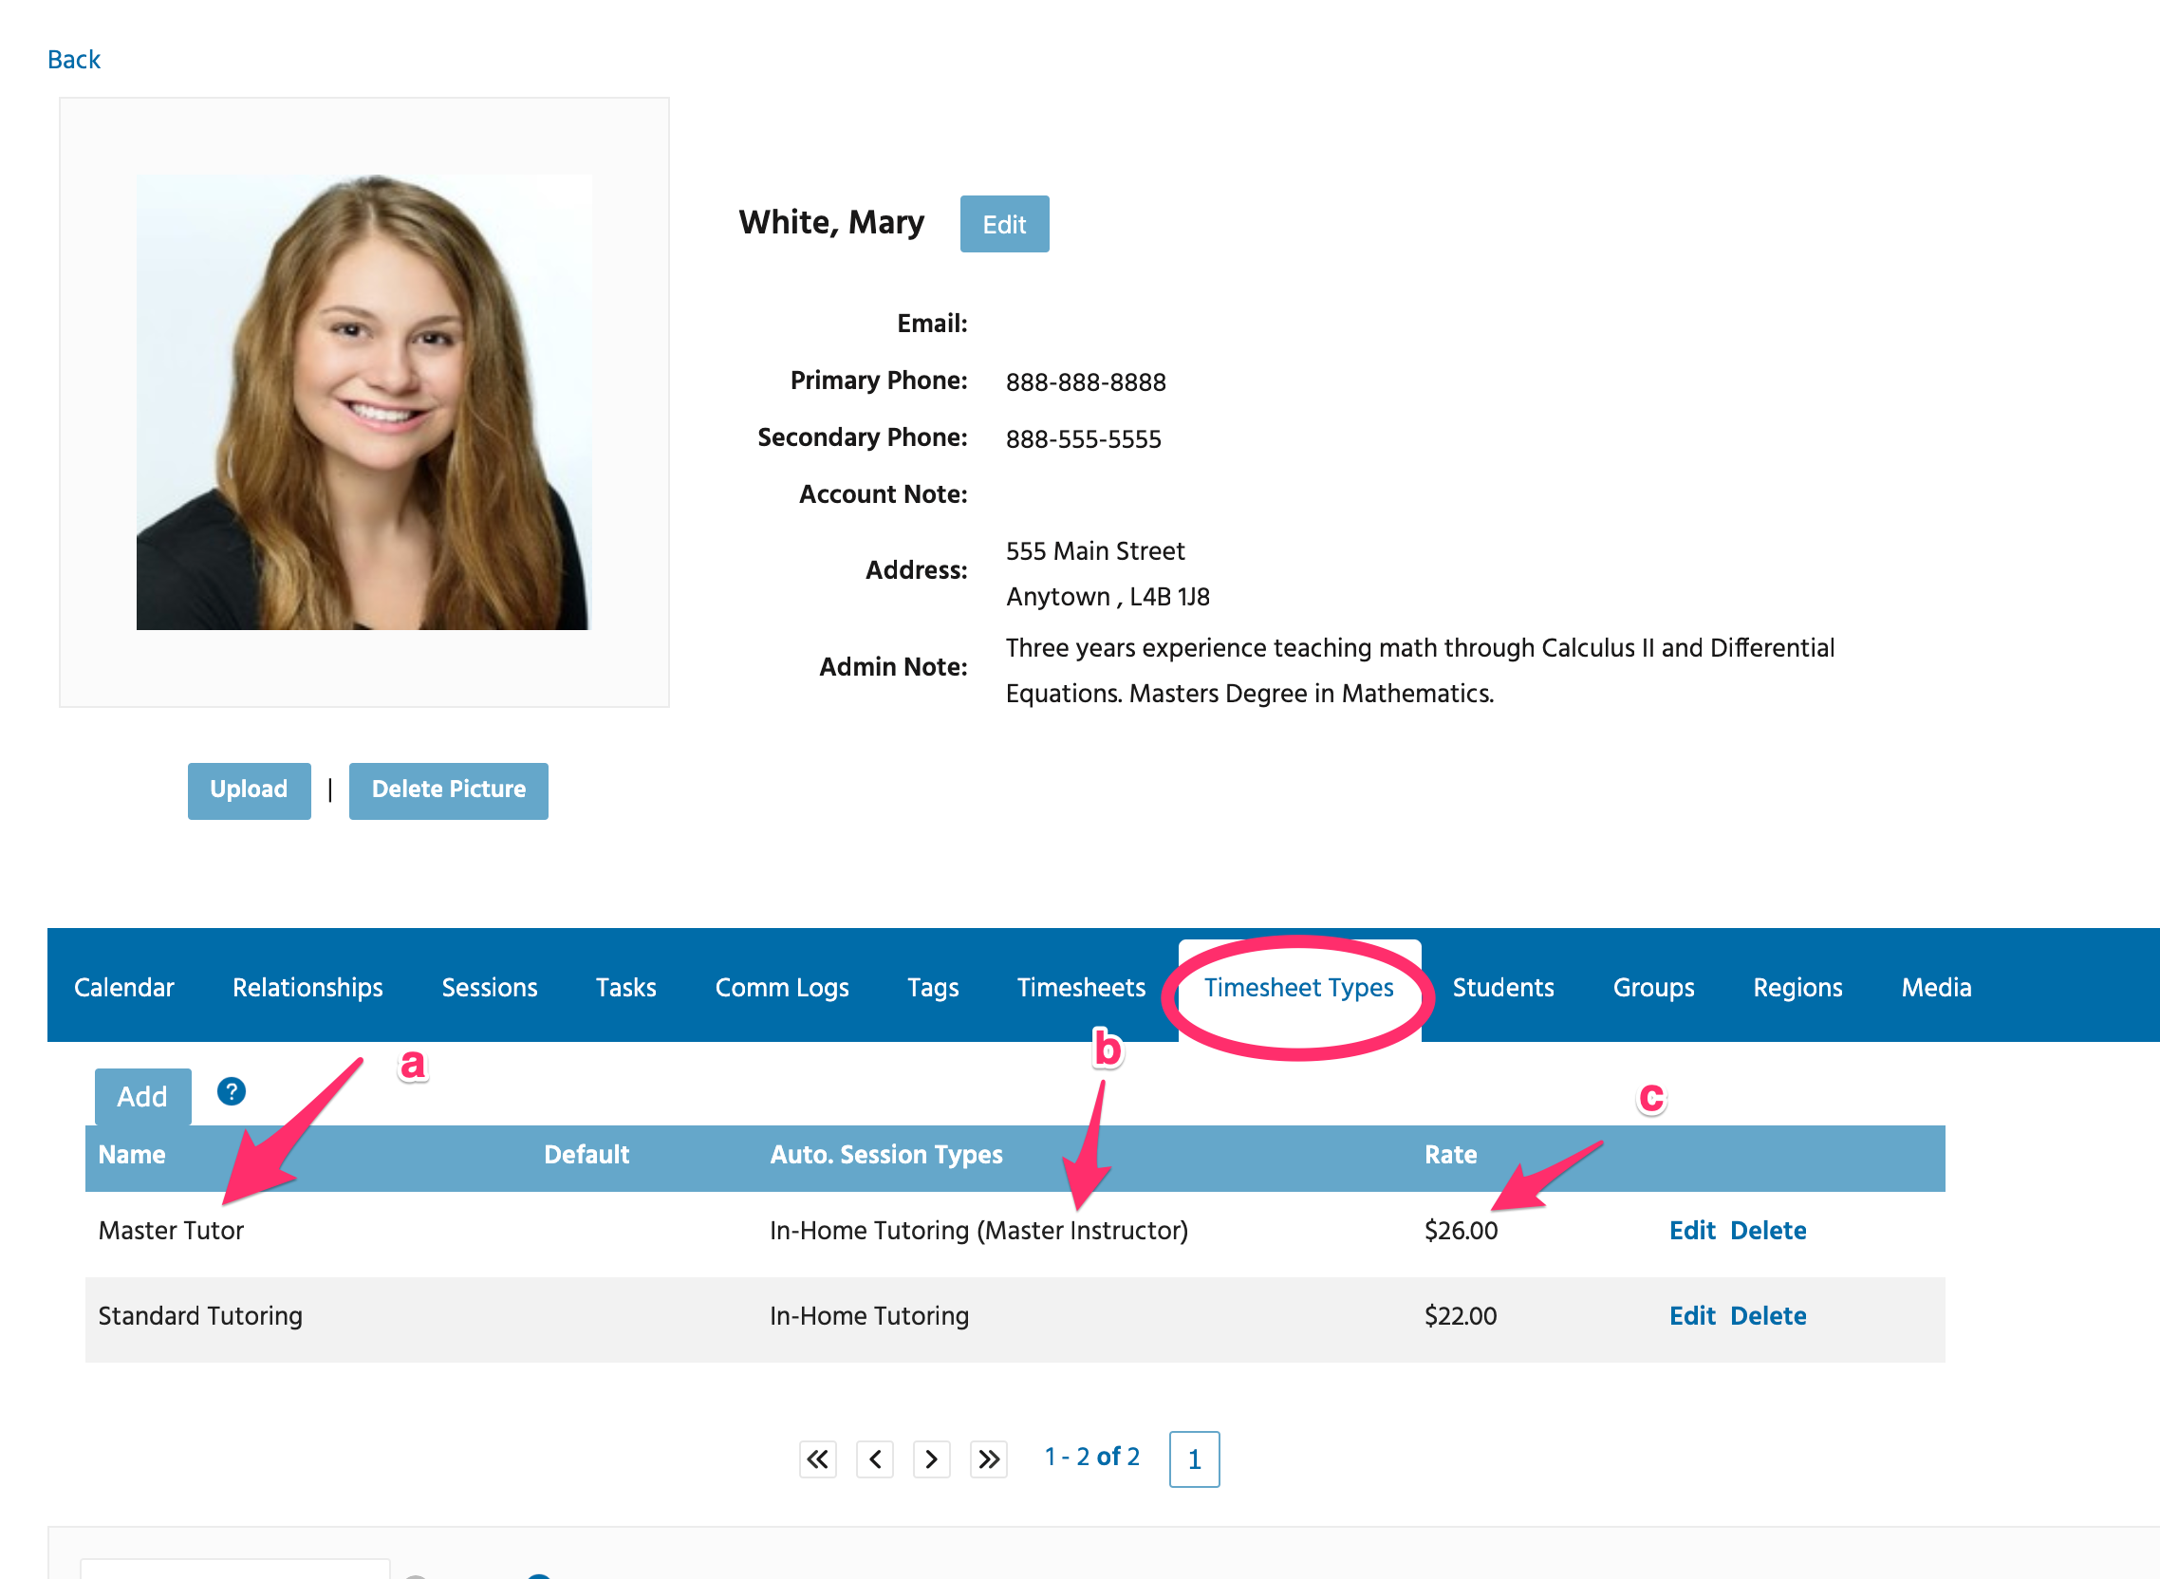

Instructor Mary White has two Timesheet Types associated with her account. If she didn’t have these Timesheet Types listed, then the system would have used the Default Timesheet Types associated with her Session Logs’ Session Types. However, Mary does have the a) Timesheet Type “Master Tutor” listed with the b) Auto Session Type “In-Home Tutoring (Master Instructor), paid at the c) override rate of $26/hr. A new “Master Tutor” timesheet paid at $26 will be created every time Mary creates a Session Log using the “In-Home Tutoring (Master Instructor)” Session Type.

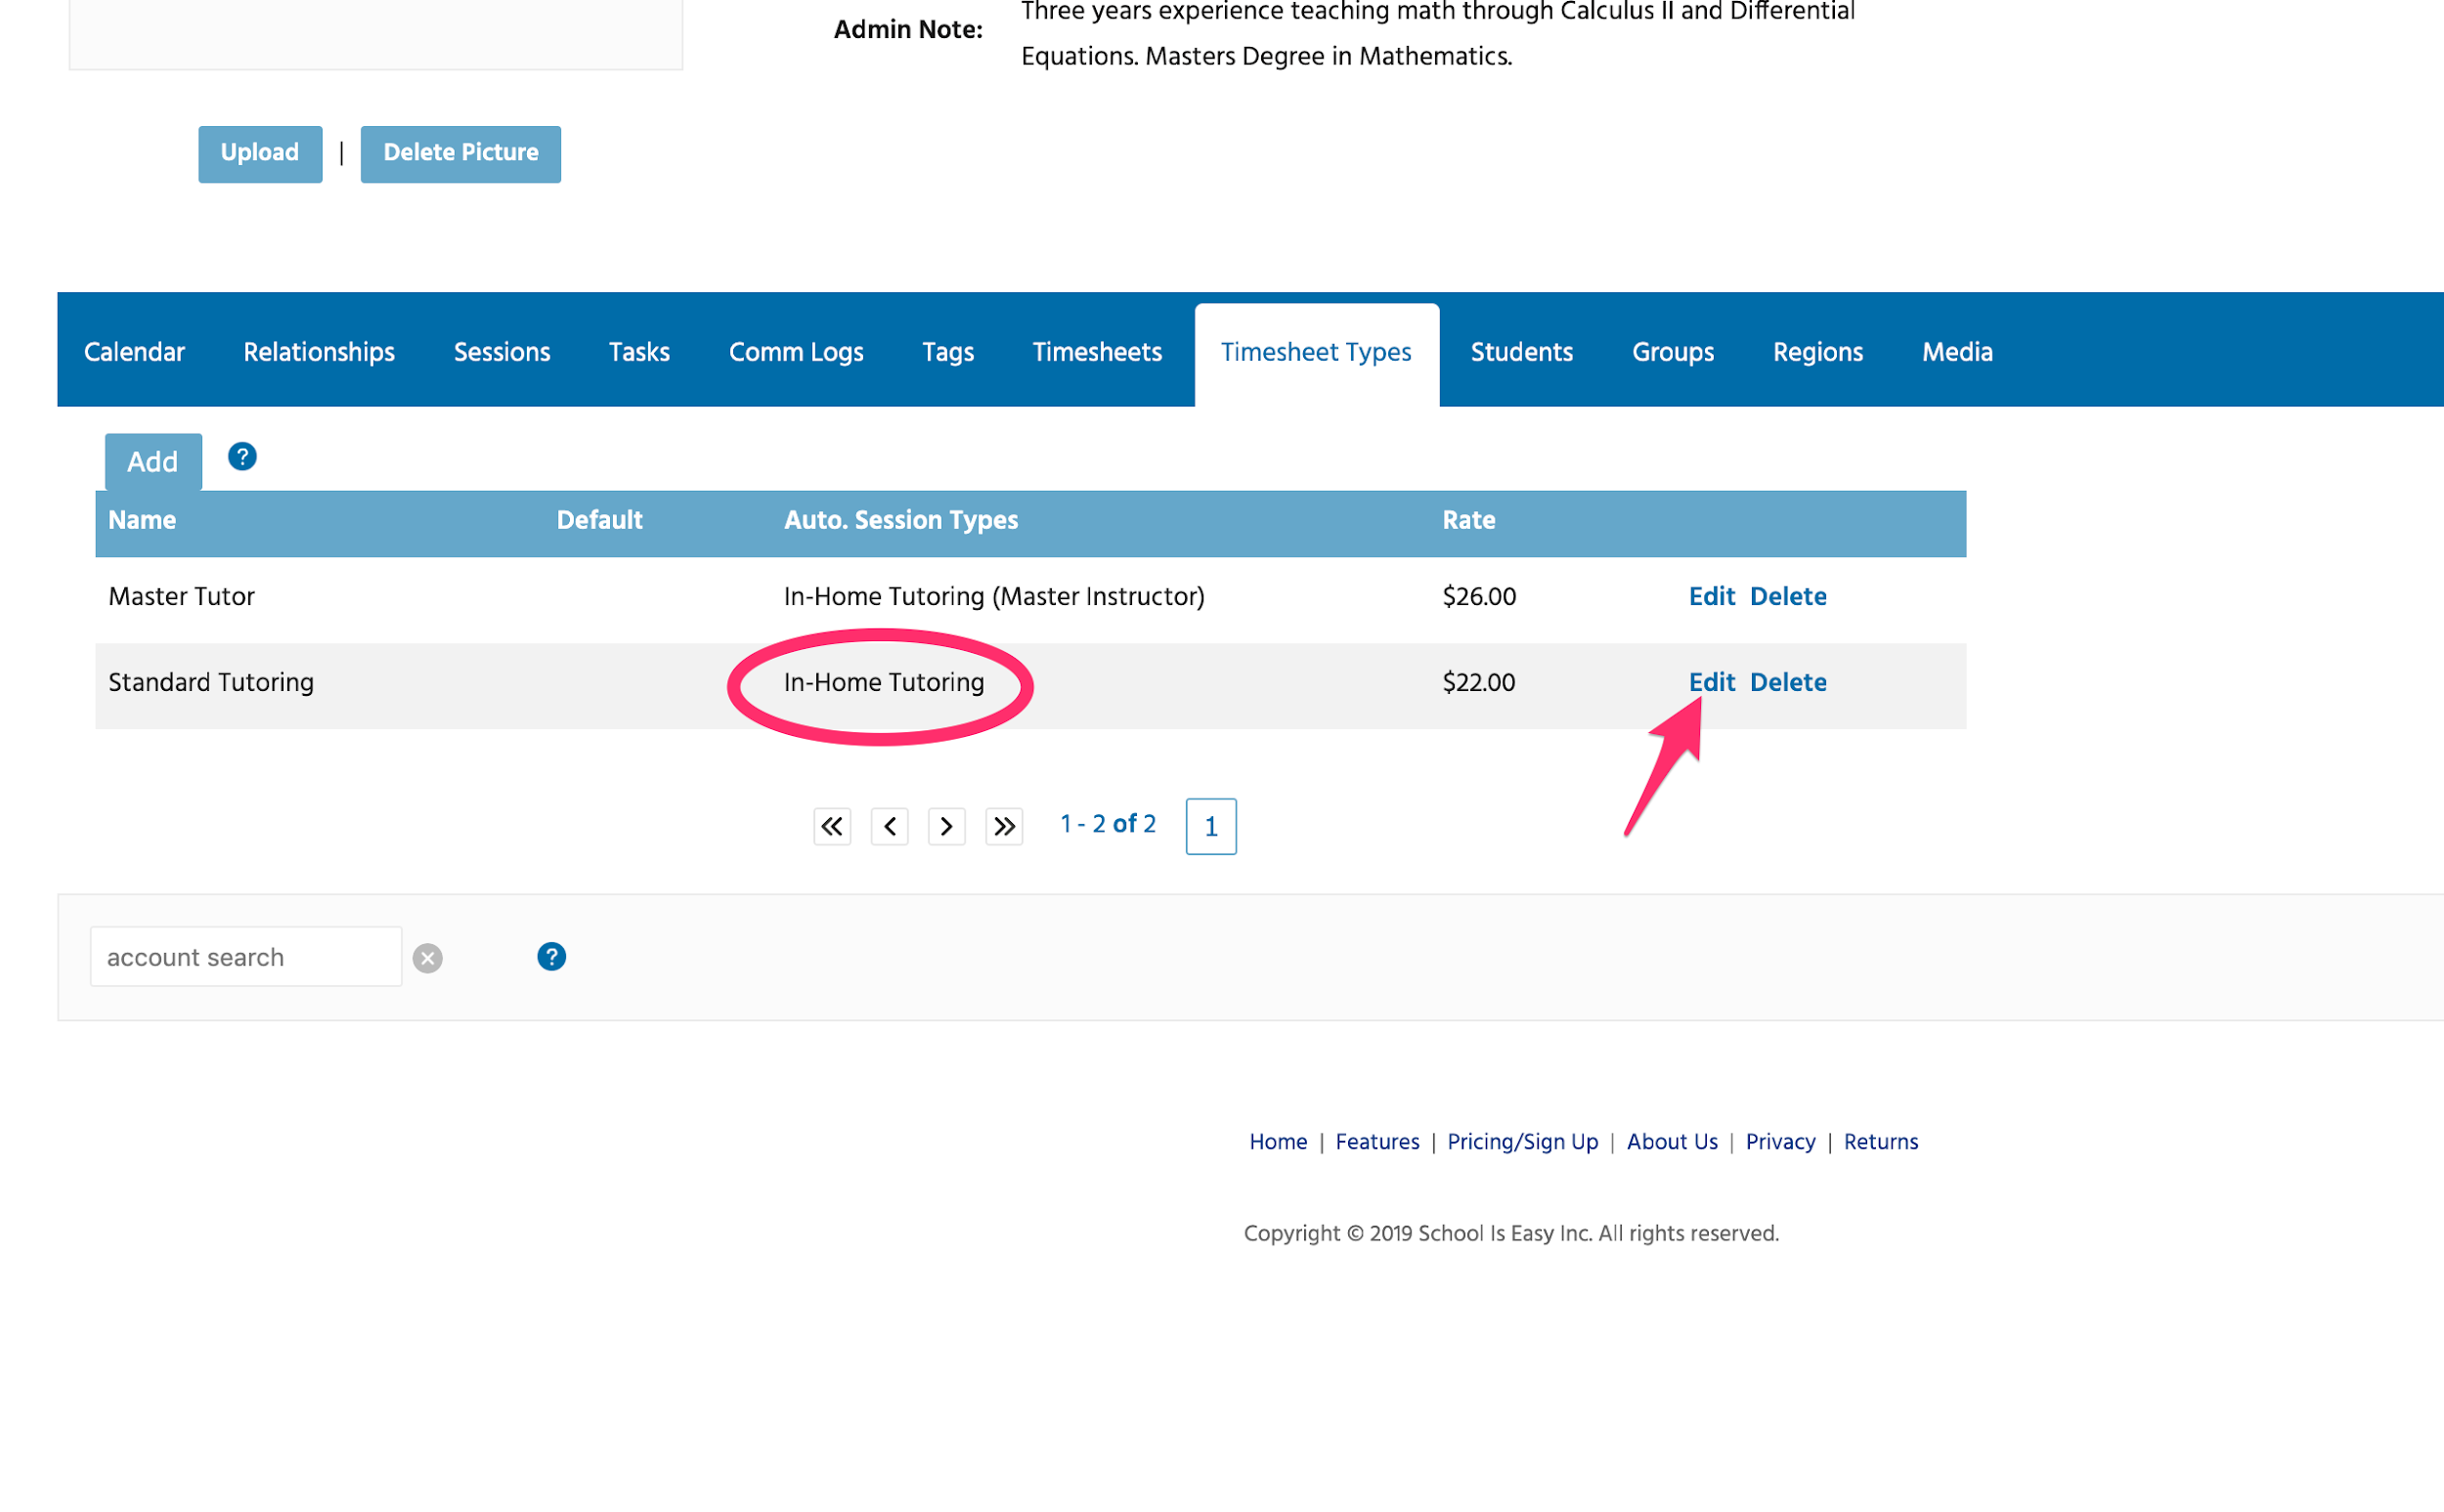

We can create associate additional Timesheet Types or edit existing Timesheet Types under the instructor’s account.

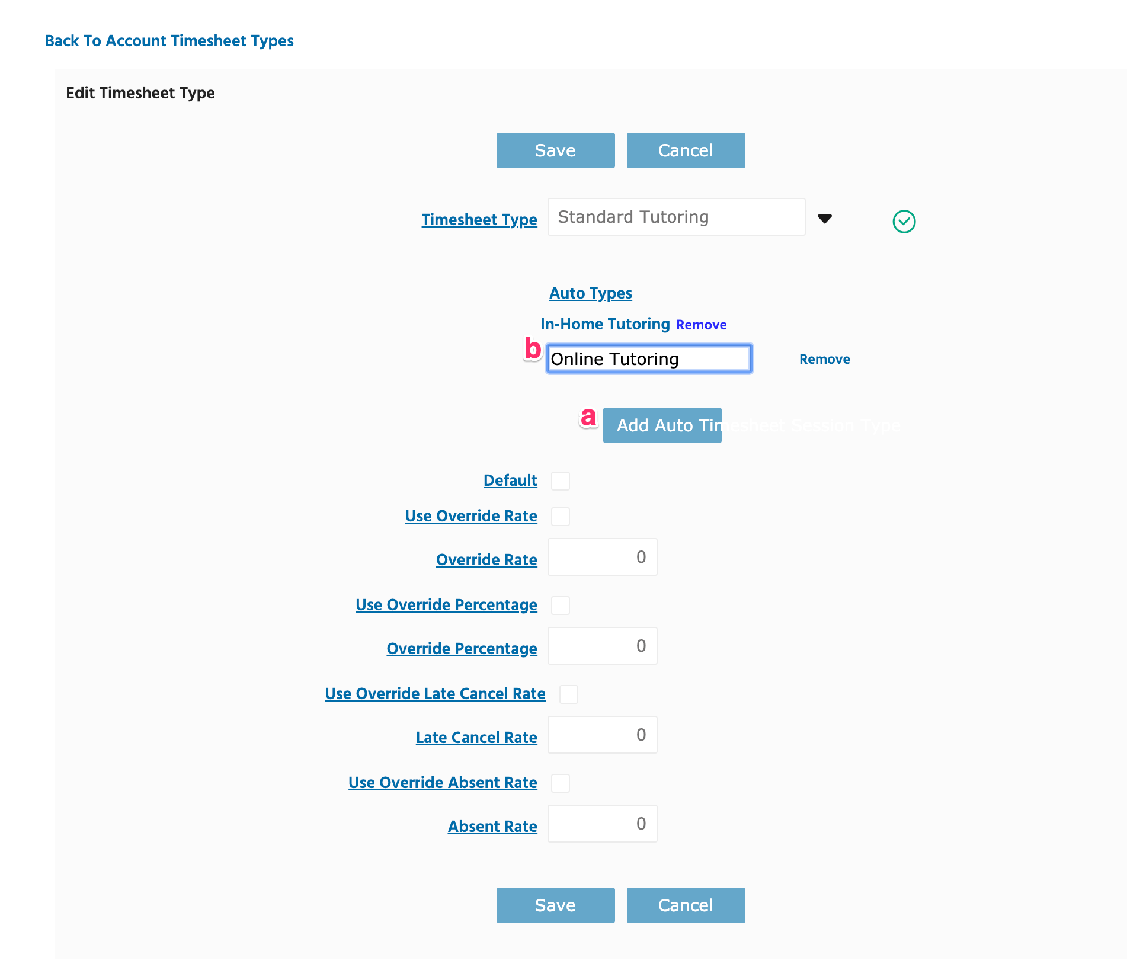

In addition to the “Master Tutor” Timesheet Type, Mary had the “Standard Tutoring” Timesheet Type associated with her account.   
See above that for Mary’s account, this “Standard Tutoring” Timesheet Type already was associated with “In-Home Tutoring” Session Type. Remember, this means that any time Mary creates a session log with In-Home Tutoring, she will receive a “Standard Tutoring” timesheet entry. See above that “Use Override Rate” is not checked. This means that Mary will receive the default rate we setup under the admin tab.

Now let’s say that we also want Mary to receive this same “Standard Rate” timesheet entry when she creates sessions with the “Online Tutoring” Session Type. To do this, we click on the Add Auto Time (Yeah, need to fix that button!) and enter the “Online Tutoring” Session Type, then save.

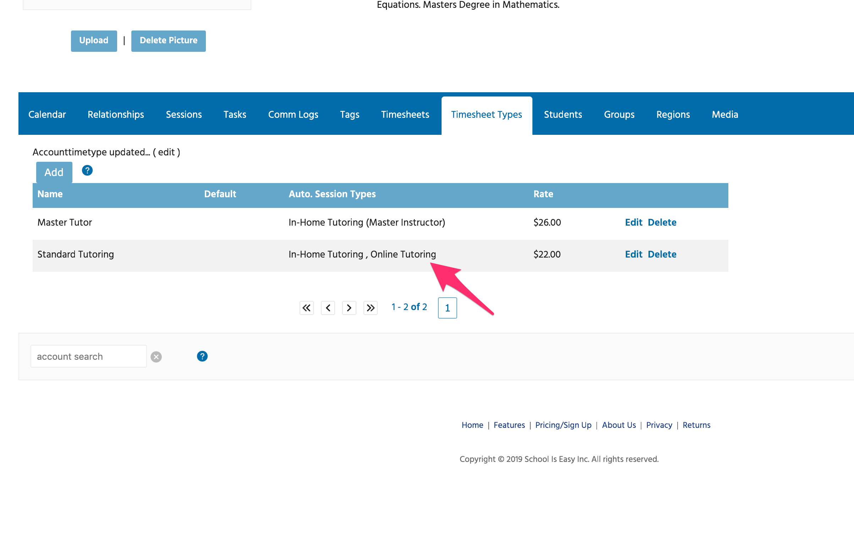

Now you can see that under Mary’s account, subtab Timesheet Types, “Standard Tutoring” timesheets paid at $22/hr will be created anytime Mary creates In-Home Tutoring or Online Tutoring session logs. Nice! We love automation!

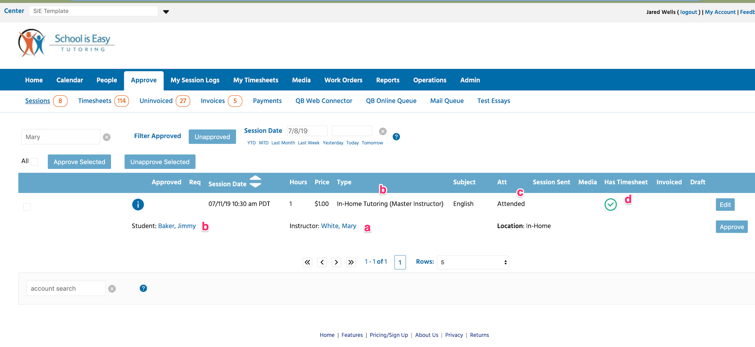

When Session Logs are created, they appear under the Approve Tab. Here you can see that:

1. Mary had a session with
2. Jimmy Baker
3. Using the In-Home Tutoring (Master Instructor) session type (*Let’s ignore the $1/hr rate we are charging this customer! Hey, it’s a test account. Cut me some slack.*)
4. And we see that a Timesheet has been created. Yea! Worked!

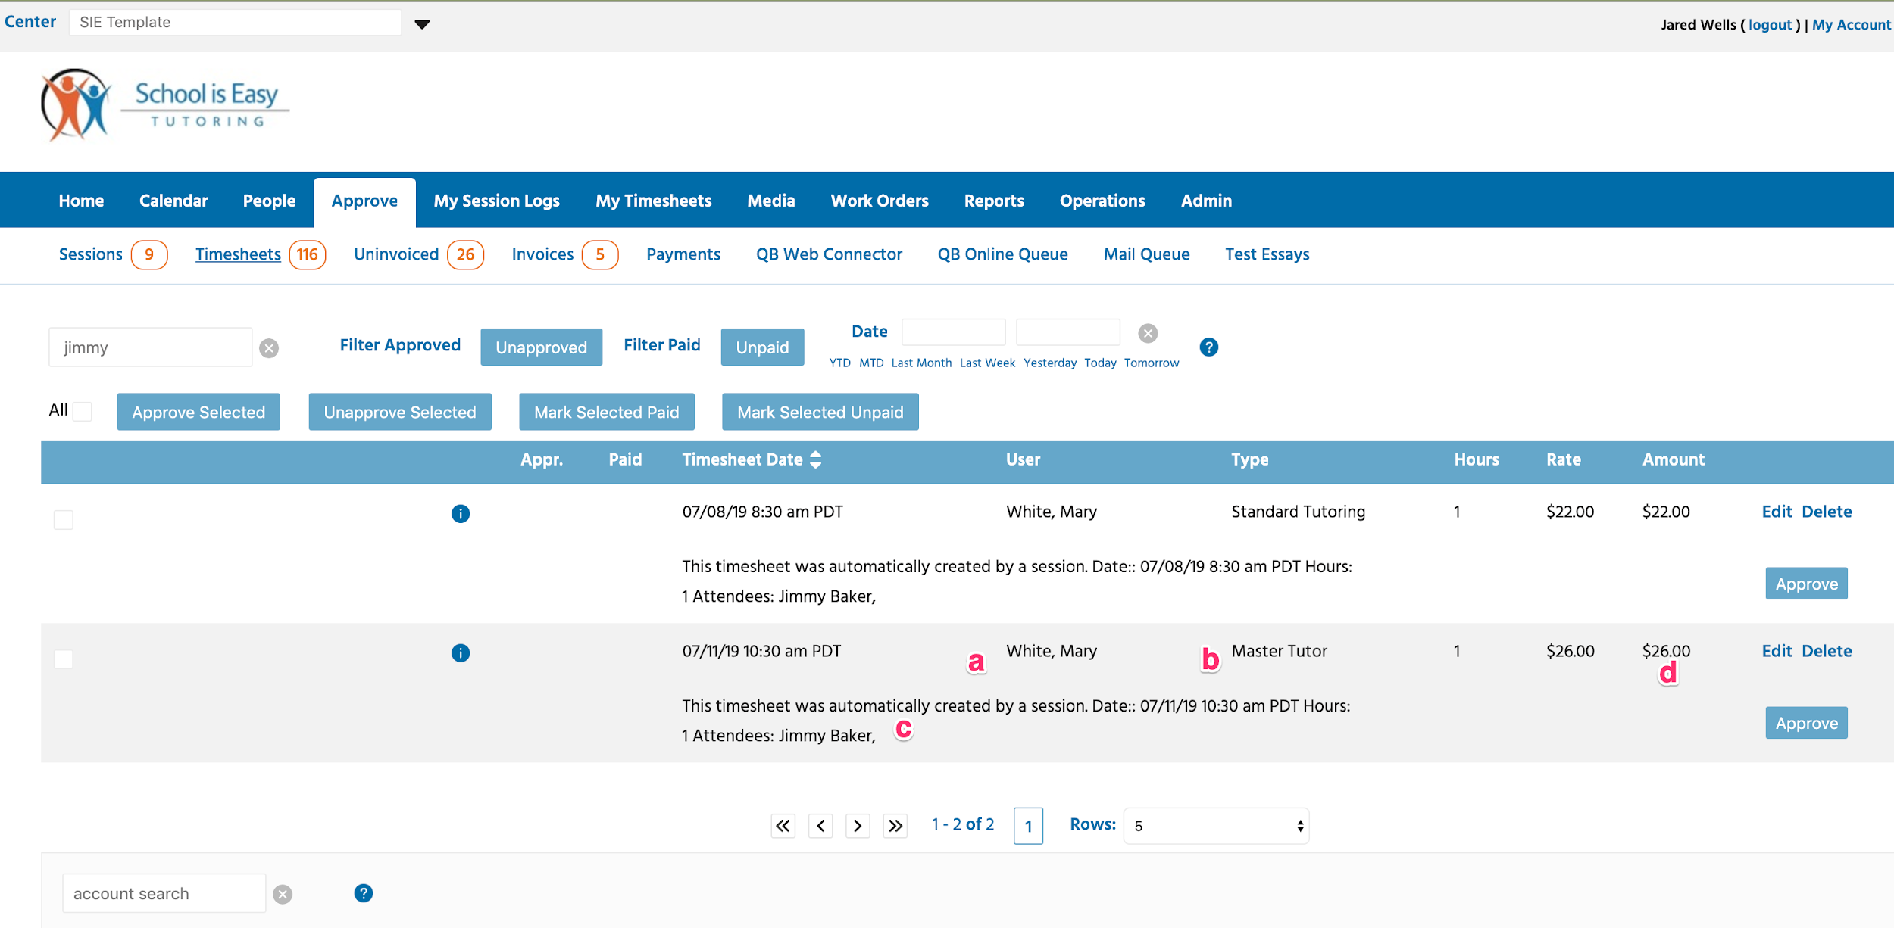

Under the Approve / Timesheets tab, we see that:

1. Mary White
2. Received a Master Tutor timesheet entry
3. For a session with Jimmy Baker. Remember, because of our setup, this was created automatically when Mary created the Session Log.
4. And, we can see that she was paid the override rate of $26/hr.

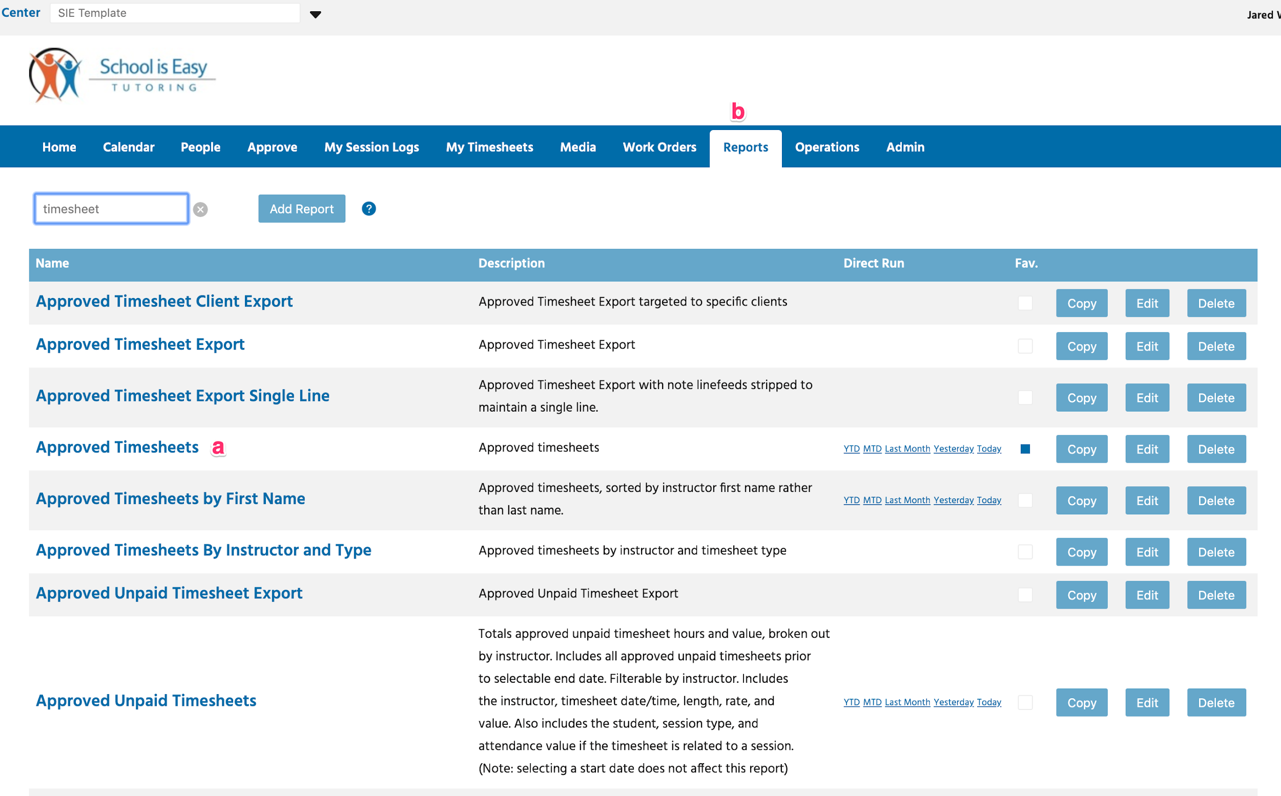

At the end of a payment period, we can run a report, Approved Timesheets.

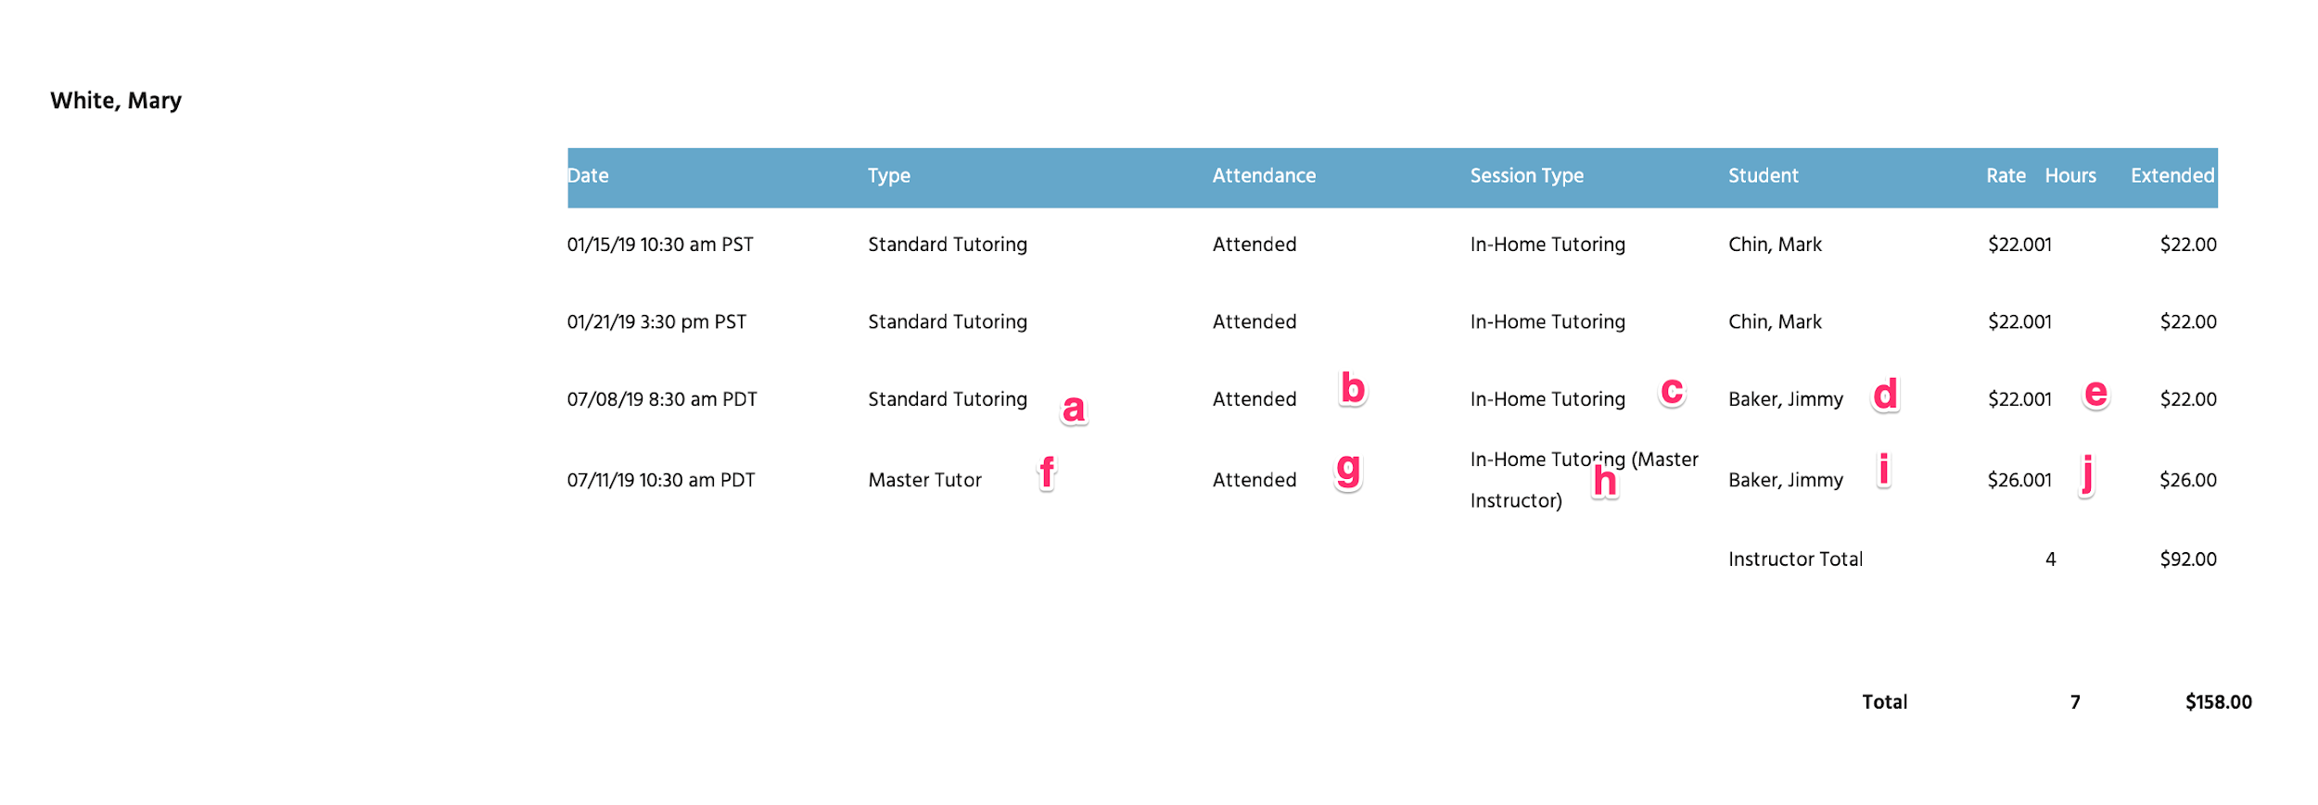

Here we see Mary’s hours for the pay period.

1. The Timesheet Entry using a Timesheet Type
2. Attendance
3. The associated Session Type
4. The Student
5. The pay rate
6. A different Timesheet Entry using a different Timesheet Type
7. With attendance
8. For a different associated Session Type
9. Student
10. And pay rate.

That’s it! Could that be easier? Probably, but where would the fun be in that?