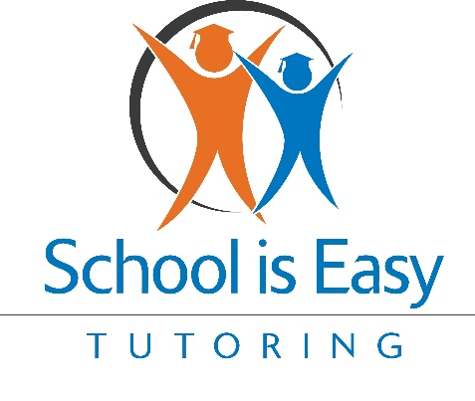
Email 1: Introduction to School is Easy and the Hero Program
Subject: Introducing the Hero Program: Partnering to Empower Your Students at No Cost
Dear [Counselor’s Name],
I hope you’re doing well. My name is [Franchisee’s Name], and I’m the [Owner/Director] of the local "School is Easy" tutoring service in [City/Region]. I’m reaching out to introduce you to our Hero program—a unique initiative designed to empower students by helping them build confidence and improve their academic performance, all at no cost to you.
The "Hero program," which stands for "Help Children Be the Hero of Their Own Story," provides personalized tutoring tailored to meet each student’s needs. We believe that every student has the potential to be the hero of their own educational journey, and our program is here to support them every step of the way.
I would love the opportunity to discuss how this program could benefit your students. Together, we can make a significant impact without requiring any financial commitment from you.
Best regards,
[Franchisee’s Name]
[Your Title]
School is Easy [City/Region]

Email 2: How the Hero Program Supports Struggling Students
Subject: Empowering Struggling Students with Our Hero Program—No Cost to You
Dear [Counselor’s Name],
I wanted to follow up on my previous email to share more about how our Hero program can support students who are facing academic challenges. This program is designed to meet students where they are, helping them overcome obstacles and gain the confidence they need to succeed—all at no cost to you.
Our mission is to empower students to become the heroes of their own educational stories. By focusing on their individual needs, we help them not just to improve academically, but also to develop the self-belief and resilience they need to thrive.
If you think any of your students could benefit from this program, I’d be happy to discuss how we can collaborate to support their success.
Looking forward to hearing from you,
[Franchisee’s Name]
[Your Title]
School is Easy [City/Region]

Email 3: Success Stories from the Hero Program
Subject: Success Stories: How Our Hero Program Transforms Students—No Cost to You
Dear [Counselor’s Name],
I’m excited to share a story that demonstrates the impact of our Hero program. A 7th grader named Sarah was struggling with math and had lost confidence in her abilities. Through our Hero program, we provided Sarah with personalized tutoring that not only improved her math skills but also helped her rebuild her confidence.
Within a few weeks, Sarah’s grades improved, and she began to see herself as capable and strong. She even started helping her classmates with difficult problems—truly becoming the hero of her own story.
Stories like Sarah’s highlight how our Hero program can make a profound difference in a student’s life. We’d love to explore how we can bring similar success to your students, with no financial burden on you.
Best,
[Franchisee’s Name]
[Your Title]
School is Easy [City/Region]

Email 4: The Long-Term Benefits of the Hero Program
Subject: Building Long-Term Success with the Hero Program—No Cost to You
Dear [Counselor’s Name],
At "School is Easy," we’re committed to preparing students not just for their next test, but for long-term success in school and beyond. Our Hero program is designed to help students develop critical thinking, problem-solving skills, and the self-confidence needed for lifelong learning—tools that will serve them well throughout their lives. And the best part? There’s no cost to you.
By participating in the Hero program, students build a strong foundation for their futures, both academically and personally. We’ve seen students not only improve their grades but also grow into more resilient and positive individuals.
I’d love to discuss how we can bring these long-term benefits to your students, with no financial burden on you.
Warm regards,
[Franchisee’s Name]
[Your Title]
School is Easy [City/Region]

Email 5: Highlighting New Opportunities with the Hero Program
Subject: New Opportunities for Student Success with the Hero Program—No Cost to You
Dear [Counselor’s Name],
I wanted to share some exciting updates about our Hero program. We’ve recently expanded our resources to better meet the diverse needs of students in our community. Whether it’s specialized tutoring for challenging subjects or additional mentoring for those who need extra support, our Hero program is here to help—all at no cost to you.
Our commitment to making education accessible and effective for every student continues to grow, and we’re excited about the new opportunities this brings for your students.
If you’re interested in learning more, I’d be delighted to discuss how we can tailor these offerings to benefit your students, with no financial obligation from you.
Looking forward to connecting,
[Franchisee’s Name]
[Your Title]
School is Easy [City/Region]

Email 6: Encouraging Collaboration and Immediate Action
Subject: Let’s Collaborate to Support Student Success—No Cost to You
Dear [Counselor’s Name],
As the school year progresses, providing students with the right support at the right time is essential. Our Hero program has been making a significant impact, and we believe it could be a valuable resource for your students. Best of all, there’s no cost to you.
We’d love to collaborate with you to identify students who could benefit from our program and ensure they get the help they need to thrive. With limited spots available, now is a great time to start this conversation.
Please let me know if you’re available for a meeting or if there’s any way I can support your efforts to help your students succeed.
Thank you for considering this partnership,
[Franchisee’s Name]
[Your Title]
School is Easy [City/Region]

