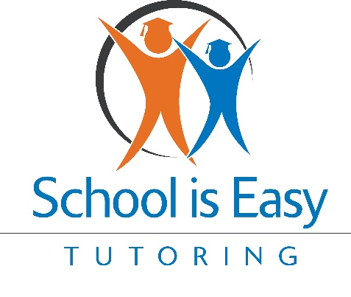
Email 1: Reconnect and Reassure
Subject: We Missed You! Let’s Get Back on Track Together
Dear [Parent's Name],
I hope this message finds you well. It’s been a little while since we last worked together, and we wanted to check in and see how things have been going with your child.
We know how much you care about your child's academic success, and we’re here to remind you that "School is Easy" is always ready to support them. Whether it's keeping up with the current curriculum or getting ahead for the next school year, we’re dedicated to helping your child reach their full potential.
Through our Hero program, we aim to empower your child to become the hero of their own story. Let’s work together again to ensure your child continues on the path to success. We’re just a phone call or email away if you’d like to discuss how we can assist further.
Best regards,
[Your Name]
[Your Title]
School is Easy

Email 2: Highlight the Importance of Consistency
Subject: Consistency is Key to Success – Let’s Keep Moving Forward
Dear [Parent's Name],
I wanted to take a moment to emphasize something we’ve always believed at "School is Easy"—consistent learning leads to lasting success. As your child continues to grow and face new challenges, maintaining a regular tutoring schedule can make all the difference.
Regular sessions not only help with immediate academic challenges but also reinforce the skills and confidence needed for future success. Returning to our tutoring program could be the key to ensuring your child doesn’t fall behind and instead thrives academically.
We’re here to support your child every step of the way, helping them become the hero of their own story. Let’s schedule a time to chat about how we can continue to help them shine.
Warm regards,
[Your Name]
[Your Title]
School is Easy

Email 3: Share a Success Story
Subject: Real Stories, Real Success – See the Difference We Make
Dear [Parent's Name],
At "School is Easy," we’ve seen incredible transformations in students just like your child. One recent success story comes to mind—a student who struggled with math returned to our program and, with consistent tutoring, moved from feeling frustrated to becoming confident and even enjoying the subject.
Every child has the potential to achieve great things, and we’re committed to helping your child unlock that potential. Returning to our program could be the first step in creating their own success story.
Would you like to discuss how we can help your child become the hero of their own story? We’re here to listen and support.
Best,
[Your Name]
[Your Title]
School is Easy

Email 4: Emphasize the Long-Term Benefits
Subject: Setting Your Child Up for Long-Term Success
Dear [Parent's Name],
As parents, we all want what’s best for our children—not just for today, but for their future. Investing in your child’s education now can pave the way for long-term success in school and beyond. The skills and confidence they gain through tutoring are building blocks for their future achievements.
Our tutoring sessions are designed to do more than just improve grades; they foster a love of learning, build self-confidence, and develop critical thinking skills that will serve your child for years to come.
Let’s continue this journey together and help your child become the hero of their own story. We’re excited to help your child reach new heights.
Sincerely,
[Your Name]
[Your Title]
School is Easy

Email 5: Introduce New or Upcoming Programs
Subject: Exciting New Opportunities for Your Child!
Dear [Parent's Name],
I wanted to share some exciting news with you—"School is Easy" has been working on new programs designed to make learning even more engaging and effective for students like your child.
Whether it’s personalized learning plans, new interactive materials, or additional support for challenging subjects, we’re constantly evolving to meet the needs of our students. Returning now means your child can benefit from these new resources and continue their educational journey with the best support available.
If you’d like to learn more about these new offerings, I’d be happy to discuss them with you. Together, we can help your child become the hero of their own story.
Looking forward to hearing from you,
[Your Name]
[Your Title]
School is Easy

Email 6: Create a Sense of Urgency and Encourage Action
Subject: Don’t Miss Out – Let’s Secure Your Child’s Spot Today!
Dear [Parent's Name],
As the school year progresses, now is the perfect time to ensure your child stays on track and even gets ahead. Our schedule is filling up quickly, and we’d hate for your child to miss out on the opportunity to continue their academic journey with us.
By returning to our tutoring program now, you can secure your child’s spot and give them the tools they need to excel. Let’s not wait until it’s too late—let’s get started today.
Please reach out to book your next session or to discuss any questions you might have. We’re here to help your child continue to grow and become the hero of their own story.
Best regards,
[Your Name]
[Your Title]
School is Easy

