OPUS V2 Sending Emails – *How-To Guide*

In this guide, we will go over how to send emails to a single parent or tutor, how to send an email to all of your parents or tutors, and how to use email templates.  
  
**Email to Singular Parent or Tutor**

1. Click on the name of parent or tutor you want to send an email to.

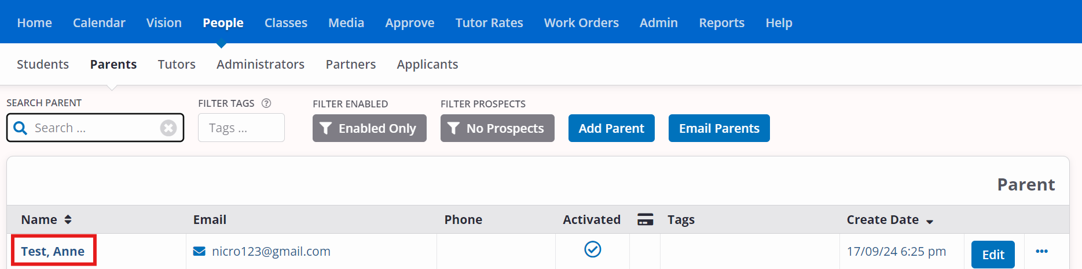

1. 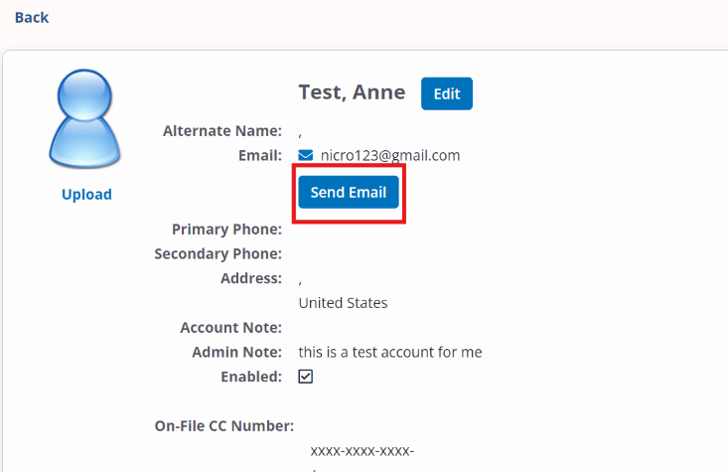Under the area where it shows their email address, click on the Send Email button
2. From there, fill out all of the information on the screen and then click Send

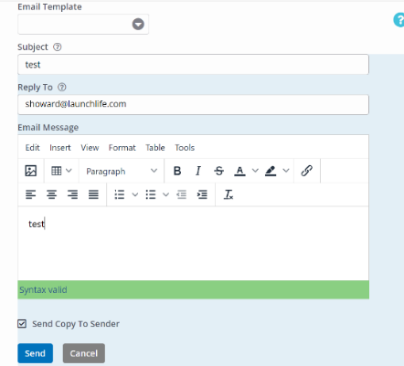

**Email to All Parents or Tutors**

On OPUSV2, you have the ability to mass email all of your parents or tutors.

1. Navigate to the Parents or Tutors tab and click on Email Parents or Email Tutors

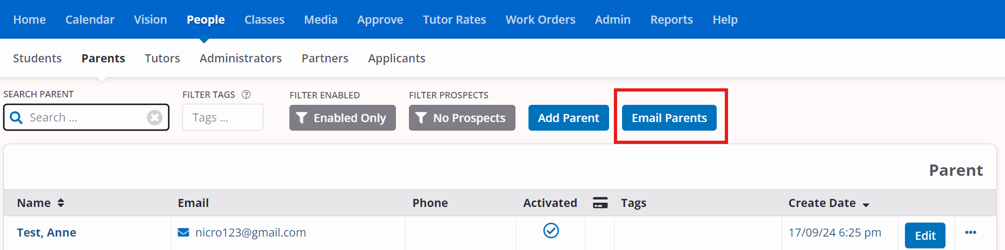

1. From there, fill out all of the email information and then click send. This will send the email to all of your active parents or tutors

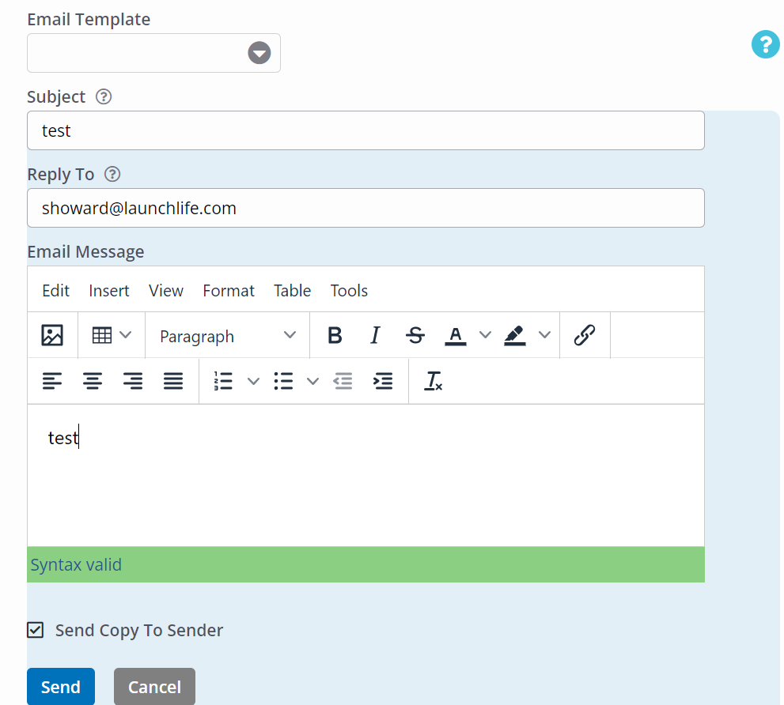

1. If you would rather use a template, click on the arrow in the Email Template box

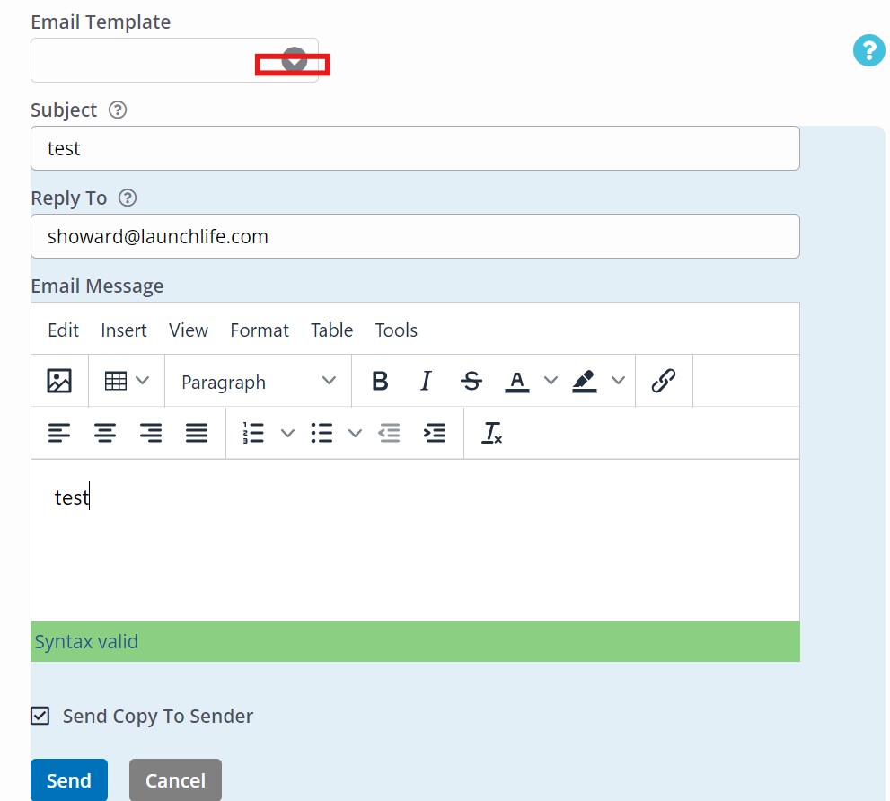

1. Then select the template you would like to use

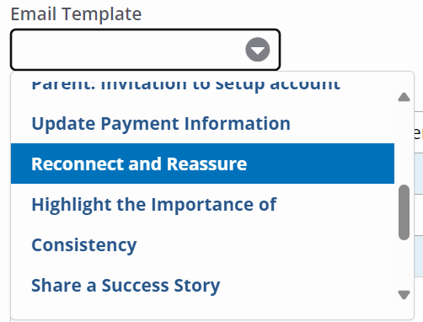

1. Once you have selected the email template, all details will be automatically filled out with your template