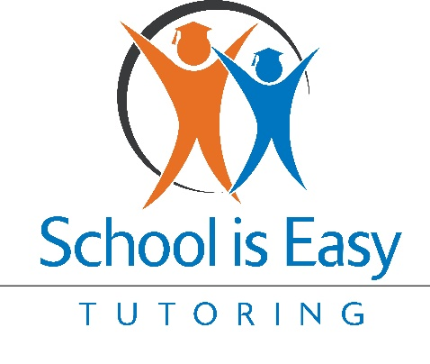

Program Rollout Document: Marketing the "School is Easy" Hero Program to School Guidance Counselors

Overview
The "School is Easy" franchise is launching a strategic email marketing campaign aimed at school guidance counselors, a key demographic in supporting struggling students. This six-part email series introduces the Hero Program, a unique initiative designed to empower students by helping them become the heroes of their own educational journeys. Each email in the series progressively builds on the previous message, showcasing the value of the Hero Program and encouraging collaboration with school counselors—all at no cost to them.
All email templates along with the rollout documents can be found in the School is Easy Help Centre HERE

Email Series Breakdown

Email 1: Introduction to School is Easy and the Hero Program
- Objective: Introduce the Hero Program and establish initial contact.
- Key Value Proposition: Highlight that the Hero Program is designed to empower students by building their confidence and improving academic performance, with no financial commitment required from the school.
- Hero Program Focus: "Help Children Be the Hero of Their Own Story" by providing personalized tutoring tailored to individual student needs.
- Call to Action: Encourage a discussion on how the program can benefit their students.

Email 2: How the Hero Program Supports Struggling Students
- Objective: Provide more detail on how the Hero Program addresses the needs of students who are academically challenged.
- Key Value Proposition: Emphasize that the program meets students where they are, focusing on both academic improvement and personal growth, fostering resilience and self-belief.
- Hero Program Focus: Reinforce the mission of helping students gain confidence and overcome academic obstacles.
- Call to Action: Invite counselors to discuss potential collaboration to support struggling students.

Email 3: Success Stories from the Hero Program
- Objective: Showcase real-life success stories to demonstrate the effectiveness of the Hero Program.
- Key Value Proposition: Provide a compelling narrative (e.g., Sarah’s story) to illustrate how the program can transform a student’s academic and personal life.
- Hero Program Focus: Highlight how personalized tutoring can lead to significant improvements in both academic performance and self-confidence.
- Call to Action: Encourage counselors to explore how similar success stories can be created for their students.

Email 4: The Long-Term Benefits of the Hero Program
- Objective: Communicate the lasting impact of the Hero Program on students’ academic and personal development.
- Key Value Proposition: Stress that the program prepares students for lifelong learning by developing critical thinking, problem-solving skills, and self-confidence.
- Hero Program Focus: Emphasize the program’s role in building a strong foundation for students' futures.
- Call to Action: Discuss how these long-term benefits can be made available to their students.

Email 5: Highlighting New Opportunities with the Hero Program
- Objective: Update counselors on the expanded resources and opportunities within the Hero Program.
- Key Value Proposition: Introduce new offerings, such as specialized tutoring and mentoring, to address a broader range of student needs.
- Hero Program Focus: Reinforce the program’s commitment to making education accessible and effective for all students.
- Call to Action: Offer to tailor the program’s resources to meet the specific needs of their students.

Email 6: Encouraging Collaboration and Immediate Action
- Objective: Urge counselors to take immediate action and collaborate with the Hero Program.
- Key Value Proposition: Stress the importance of timely support for students and the significant impact the program has already made.
- Hero Program Focus: Emphasize the collaborative nature of the program and the limited availability of spots.
- Call to Action: Encourage scheduling a meeting to discuss student needs and program implementation.

Key Highlights
- Hero Program: The core of the email series is the Hero Program, which empowers students by focusing on personalized support tailored to their unique challenges, enabling them to become the heroes of their own educational journeys.
- Cost-Free Collaboration: A crucial aspect of the messaging is that the program is offered at no cost to the counselors or the schools, making it an easy and beneficial partnership.
- Progressive Engagement: The emails are designed to gradually build interest and trust, moving from introduction to action, while consistently reinforcing the value of the Hero Program.
- Success Stories: Real-life examples of student success are used to create a relatable and persuasive narrative, encouraging counselors to envision similar outcomes for their own students.
- Call to Action: Each email ends with a clear and compelling call to action, inviting counselors to engage further with the program, ensuring ongoing communication and eventual partnership.

This document serves as a guide for rolling out the email marketing campaign, ensuring consistency in messaging and maximizing the impact of each communication touchpoint with school guidance counselors.

