

**Tutor Orientation, Part I**

**Tutor Handbook - Working in Opus**

# 

# 

# Welcome to School is Easy Tutoring

Outlined below are key elements which make up our Brand - what we are known for. Please take the time to not only review and read through each element but embrace and take ownership of them as well. Our Brand comes alive through us and through You; in conversation, attitude and behaviours – essentially, through every interaction we, and you have with our students, parents and the teachers we work with.

We are very excited to have you join us.

Take the time to enjoy the process. Tutoring is meant to be educational AND FUN.

## Our Vison for School is Easy Tutoring

Empowering students with confidence and skills to succeed in their personal and career goals.

## Our Mission outlines what we focus on as we work toward fulfilling our vision.

School is Easy Tutoring is a full service, relationship-based tutoring service providing personalized, one-to-one tutoring support to families struggling to engage and advance in today’s education climate.

## Unique Selling / Value Proposition (USP)

In any business, competition is fierce. What is it then that sets the winners apart from the mediocre?

Answer: Successful businesses have identified and defined what it is that is “better” than what their competitors offer. At School is Easy we promote the following four elements through our advertising, our people and in conversation with our clients and community.

1. **At School is Easy, we personalize learning**

*At School is Easy* we provide in home, one-to-one tutoring. We do not own our own curriculum, rather we personalize our learning, not based on a small group, but based on that individual learner. Everything we do is customized specifically for the needs of that student.

1. **At School is Easy, we are here to meet our students’ needs & goals**

The ultimate goal of our students might be to get into university or get into nursing or to earn a scholarship. At School is Easy Tutoring, our Learning Consultation process informs what it is we need to know about the student’s challenges, how to get them to where they need to be and how to work with them to get them there.

For example, it might be organizational skills. Kids are not taught organisational skills, how to organize themselves in order to get things done on time - they might be a smart enough student, if only they could organize themselves. But they don't know how and that’s what we’ll work with them on while supporting them in the subject they are behind in.

1. **At School is Easy, we work together to make a difference**

*At School is Easy* we are not the solution – we are PART of the solution. We work together to make a difference. Communication flows between the Parent, Teachers, the Student and School is Easy staff and Tutors to ensure we have the right plan in place. We monitor progress and modify the plan as necessary.

1. **At School is Easy, we embrace diversity**

Whether it's background diversity, home situation, learning styles, etc. – all children are different: they behave differently, learn differently, cope differently etc.

At School is Easy, our doors are open to the all children who may be struggling at school.

At School is Easy we work as a team and our Opus business management system provides the transparency and visibility we need to best support our students and families.

As a School is Easy tutor, you will be responsible for a few administrative tasks and will carry out those tasks using Opus.

The following are key Opus tasks and responsibilities:

## Responding to ‘Tutor Match’ requests.

## Completing the Assigned ‘Student Task’.

## Reviewing the Student ‘Work Order’ before engaging with the student and/or parent.

## Working with SIE Director / Admin, to ensure your student sessions are scheduled in your ‘Opus Calendar’ and, up to date.

## Writing and recording ‘session reports / logs’, into Opus after each and every student session.

Each of these responsibilities are expanded upon within the following pages.

## Responding to Tutor Match Requests.

When a new student has been enrolled or needs to be matched with a tutor, your School is Easy Director or Admin Assistant will either send out a Tutor Match Request by email or will contact you directly. The communication will outline the location, subject, and preferred schedule for the sessions - if this particular assignment is a match for you, respond immediately to accept the match.

As the request may be sent to multiple tutors at a time, quick response will increase your chances of securing that assignment (match).

Working in Opus:

*When you log into Opus, your HOME screen will display (image below)*

*This screen shows that two Session Reports and one ‘Task’ require your attention.*

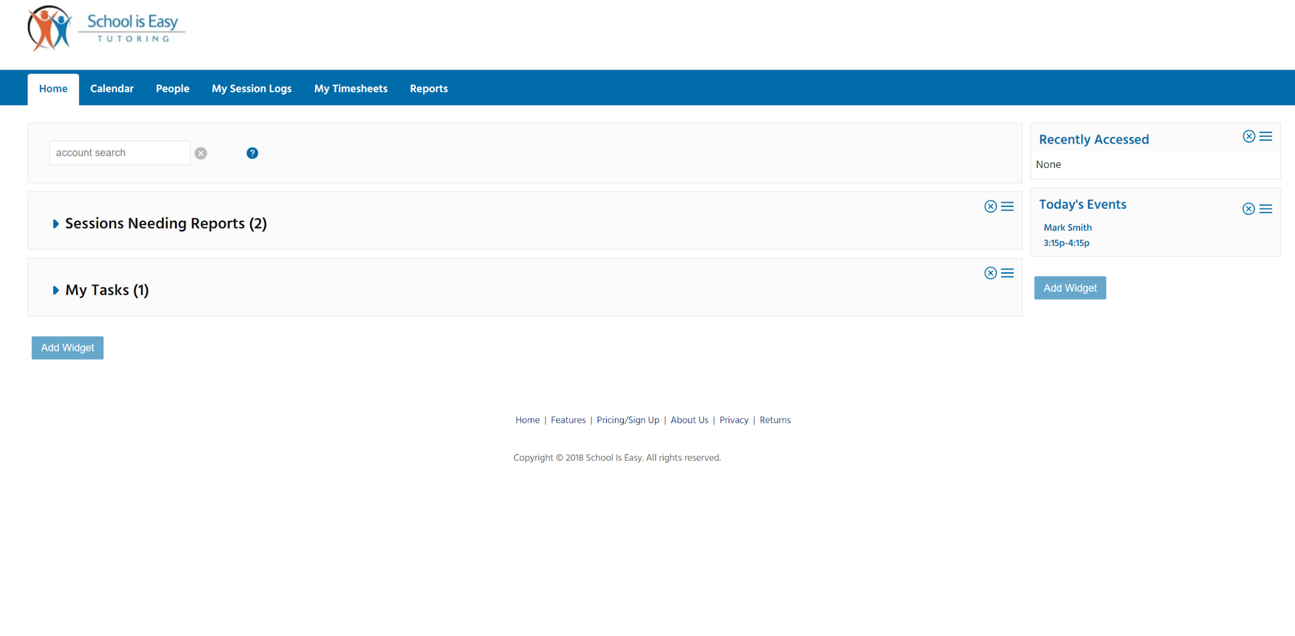

Following pages will outline the steps to take to complete outstanding responsibility areas.

## Completing the Assigned Student Task.

When you accept a match, an Opus Task will be created and an email notification will be sent to you that the task has been assigned to you. Please complete the task within 24hours of receipt.

Task: The task will ask you to contact the parent, introduce yourself and confirm date and time of the first session

Working in Opus:

The Task will appear on your Opus Home tab under the ‘My Tasks’ section.

1. *Expand the section by clicking on the blue triangle to the left of My Tasks.*
2. *Place your cursor over the information “i” icon to the left to view the full task. Click on the “i” icon if you want to keep the window open to adjust the size.*

Prior to completing the “Task’, *review the ‘Work Oder’ -* Refer to Responsibility #3, for more info on ‘Work Order’

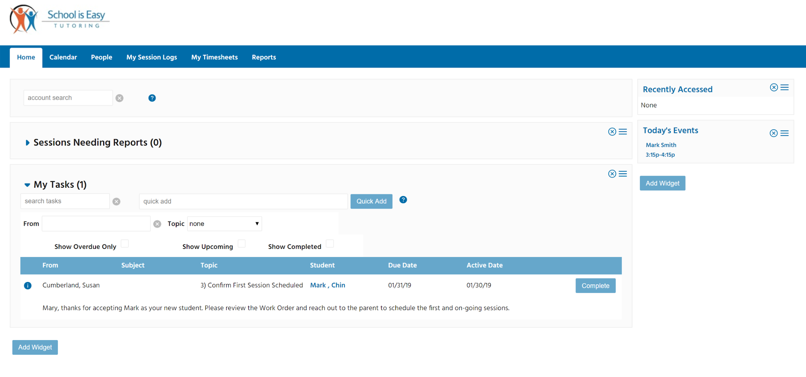

Once you have read the ‘Work Order’ and cleared up any questions you may have had with the SIE Director / Admin, proceed to completing the ‘Task’

1. *Write out the NOTE, and press SAVE*
2. When you have completed the task, *click on the Complete button (previous image, right side of window)*

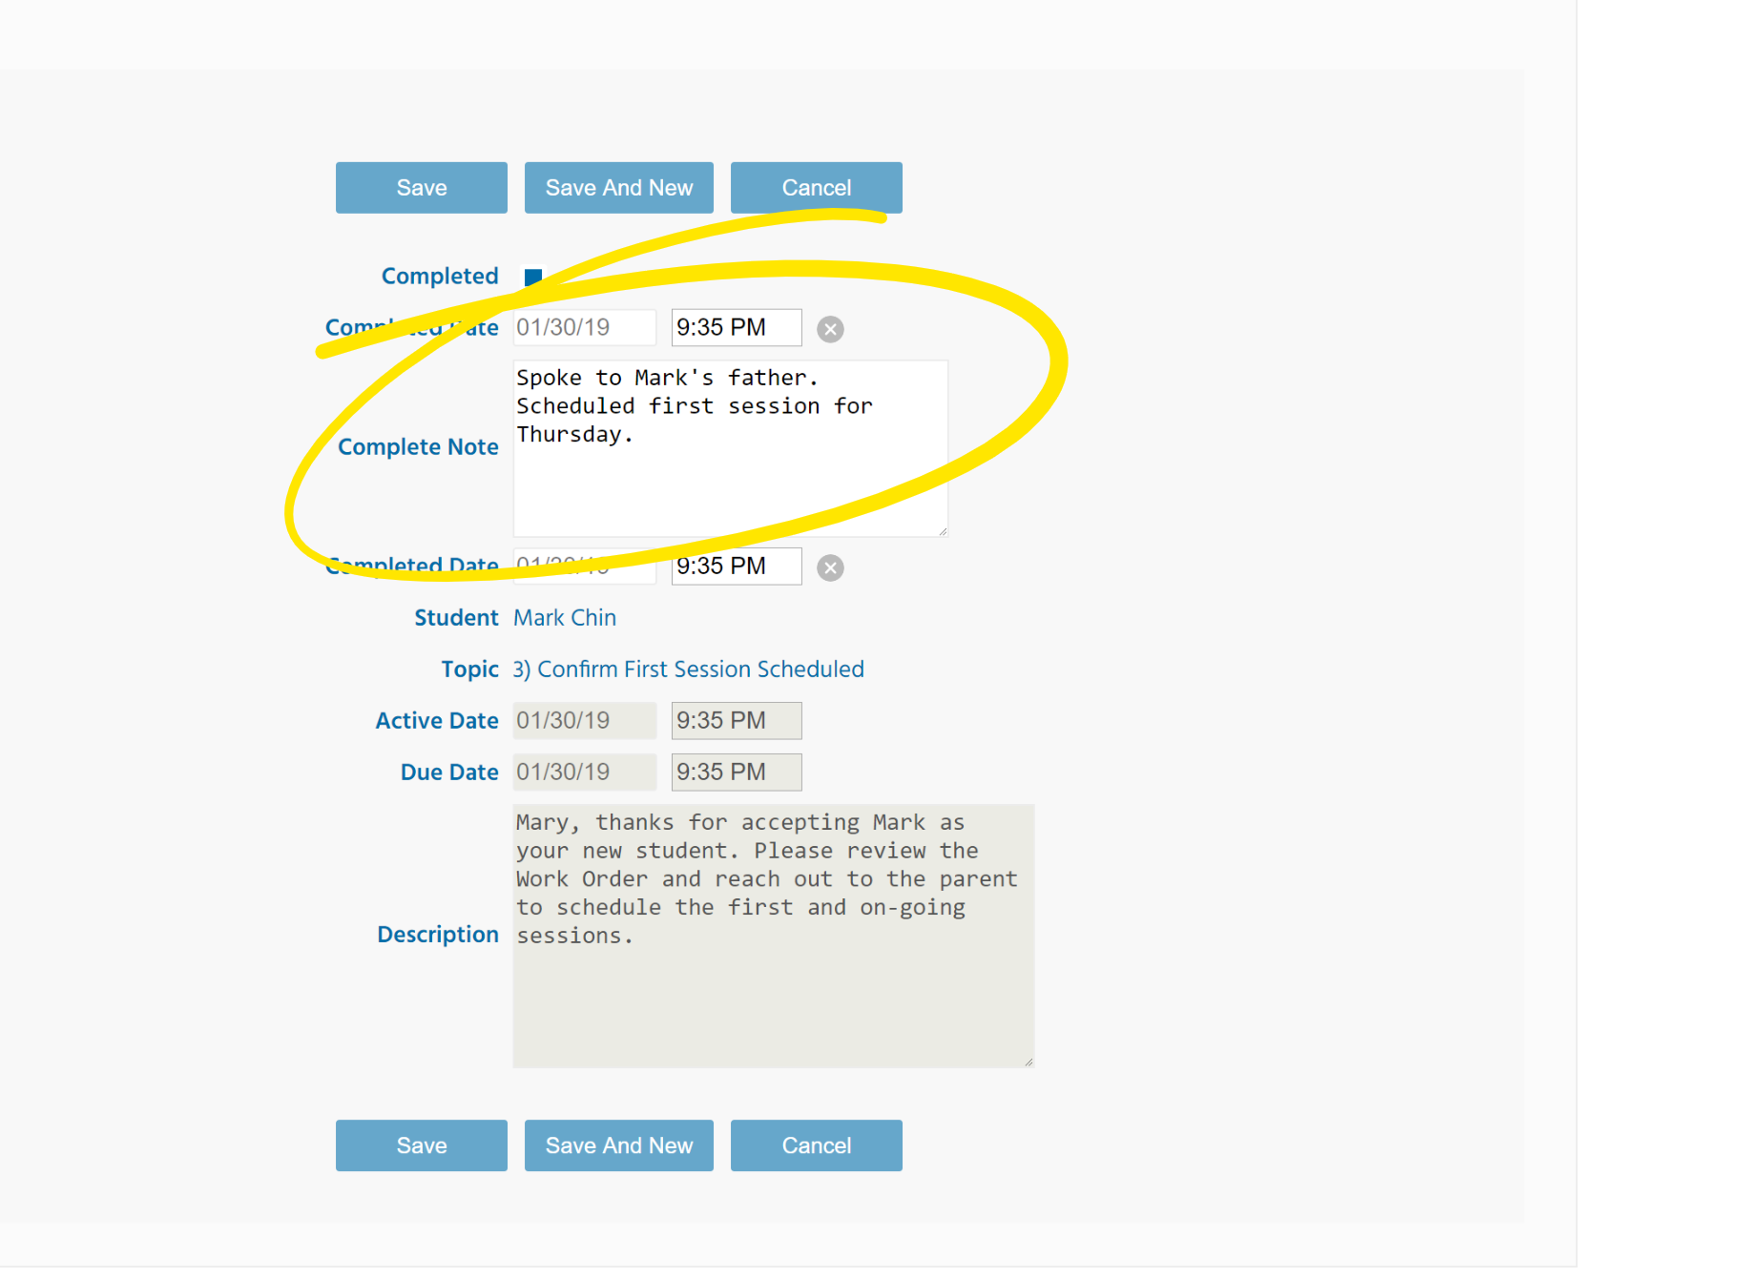

## Review the Student ‘Work Order’ before engaging with the student and/or parent.

1. *Go to the student’s record under the PEOPLE TAB or use Account Search to search for the student.*
2. Under the student account, find the WORK ORDER TAB and put your cursor over the information “i” to view the WORK ORDER.

The Work Order can be saved or printed out as a pdf by clicking on the triangle to the right side of the Work Order in the list. **It is essential that you read the Work Order before contacting the parent.**

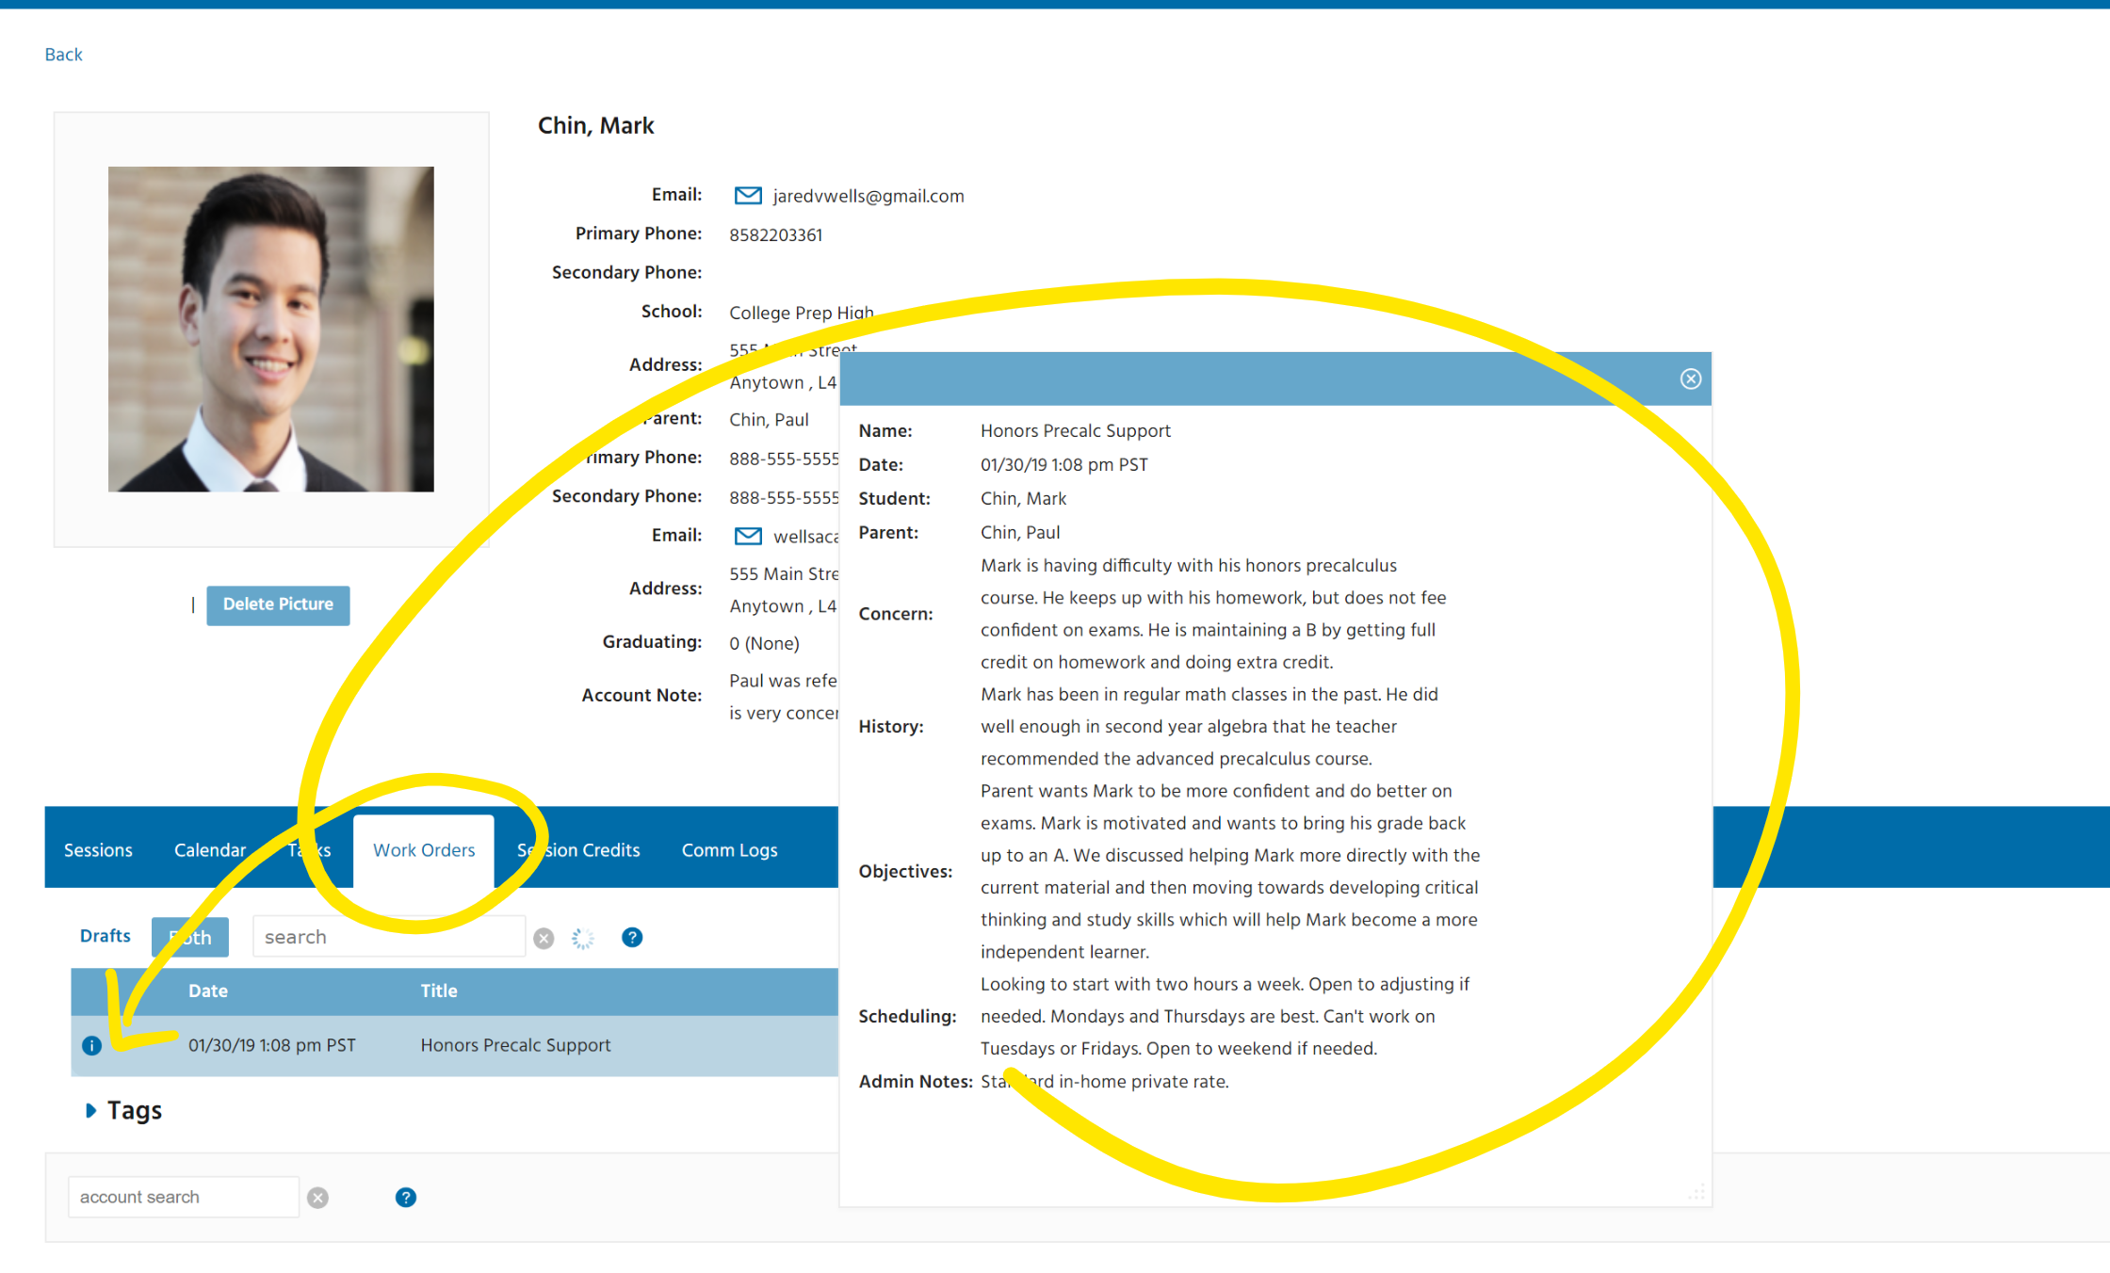

## Work with SIE Director / Admin, to ensure your student sessions are scheduled in your ‘Opus Calendar’ and, up to date.

Once schedule has been confirmed ensure it is up to date in your CALENDAR.

Note: Director or Admin usually enters the schedule into your calendar and on occasion may ask you to confirm and enter the scheduled times and dates.

Working in Opus Calendar:

1. *Locate the CALENDAR TAB to the right of HOME.*
2. Be sure you are working in your calendar (your name at left side of window)
3. *Click on the day and time slot desired*
4. *and complete the NEW EVENT FORM*. (next page)

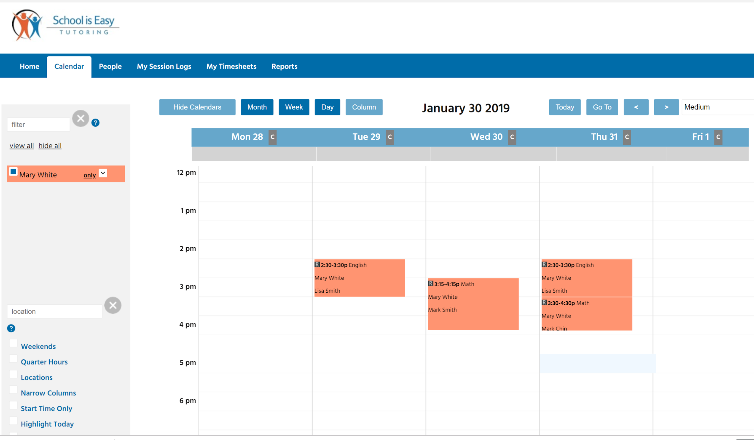

Complete EVENT FORM Window

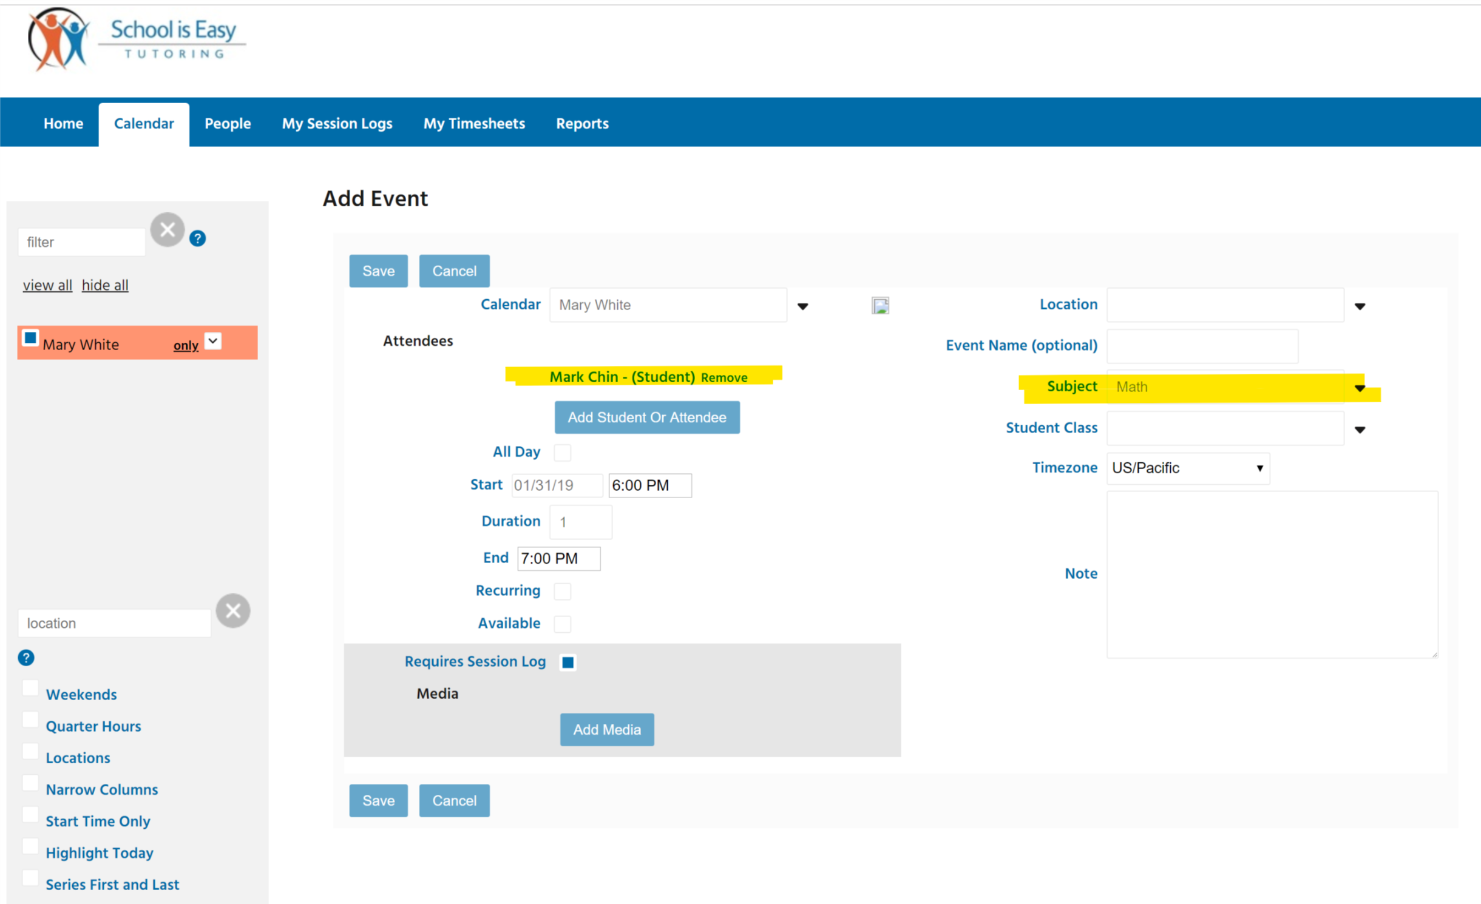

1. For a single event, one-time session (Event)
2. *Enter Student name and Subject. No other info is required*.
3. Recurring schedule; same days and times over a period of time
4. *Select Recurring*
5. *Enter an end date, or number of sessions.*

Note: If scheduling recurring / on-going sessions, you can set the end date for the end of the school year. The series of events can be edited if or when the schedule changes.

1. *Ensure all required fields are completed*.
2. *Press SAVE*

Update Calendar

As a Tutor AND **upon prior approval of your Director or Admin**, you may update the calendar when *if* the schedule changes. This is usually executed by the Director or Admin.

Working in Opus:

Changing a recurring schedule, there are two options:

1. *Drag and drop individual sessions*, OR *click on an EVENT and choose one of the options*:   
   Edit Single, Edit Series, Remove from Series, Delete Event, Delete Series, Delete Future.

Note: you cannot create events in the past.

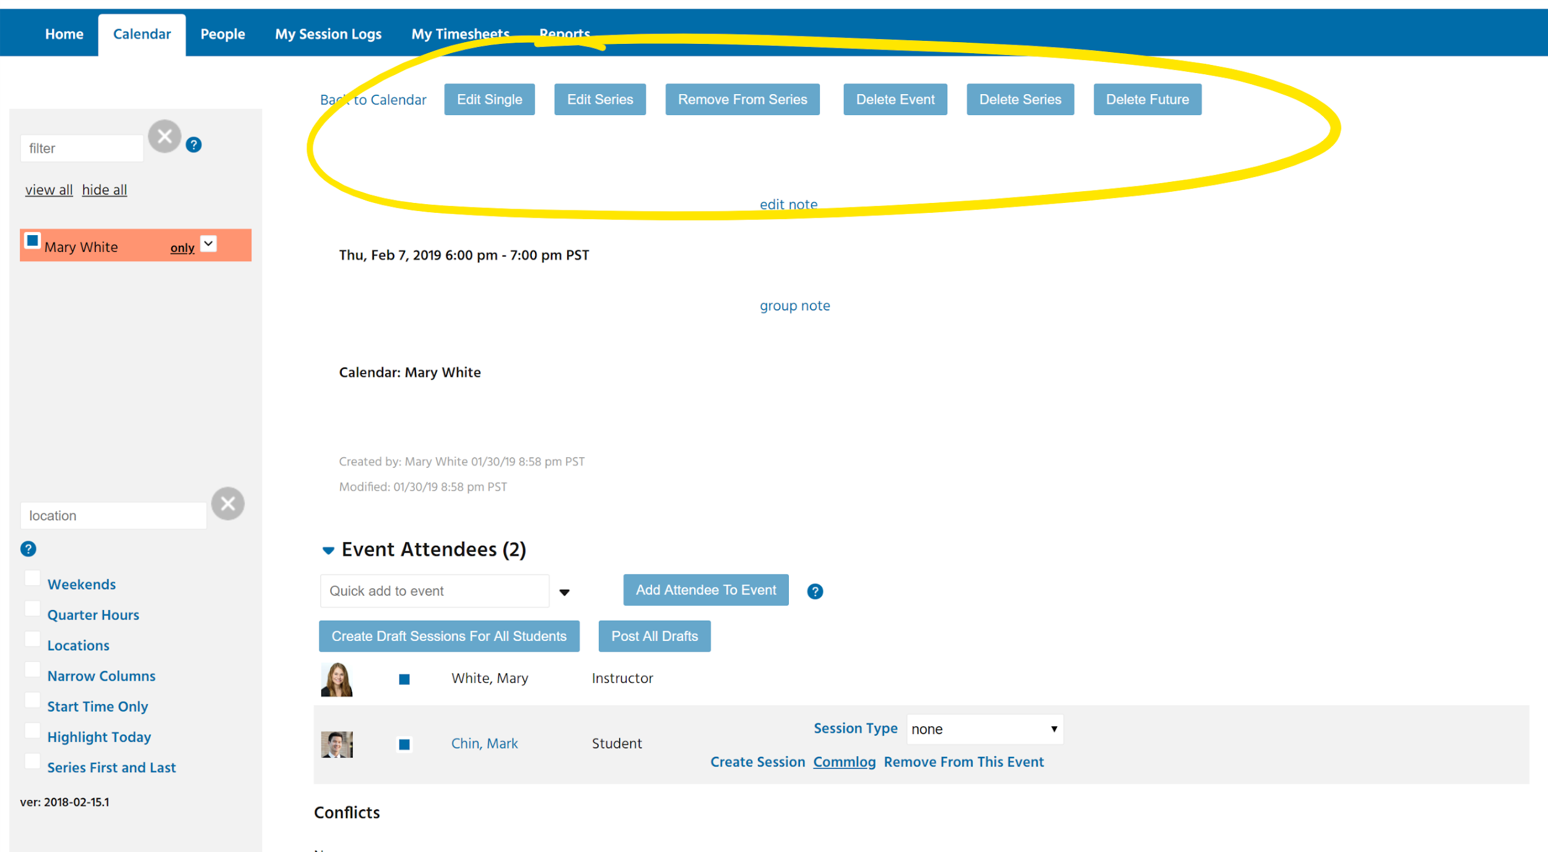

## Creating Session Logs and Recording your Session Logs

SESSION LOGS afford us the opportunity to communicate and work together toward helping struggling students be and feel more successful.

At School is Easy we are not the solution – we are PART of the solution. We work together to make a difference. Communication flows between the parent, the student, the school teachers, and School is Easy, to ensure we have the right plan in place.

Session Logs are created by the tutor, reviewed by SIE Director and then emailed to the parent. Dependent upon the arrangements made with the parent, Session Logs can also be emailed to the student and or the student’s teacher. At School is Easy, we monitor student progress and modify learning plans as necessary.

Working in Opus:

To ensure your School is Easy Director / Admin is up to speed with every session and as quickly as possible, **Session Logs are to be completed & sent during the last 5 minutes of each session.**

1. In CALENDAR TAB, *click on the scheduled Calendar Event*, then
2. *click on “Create Session”*

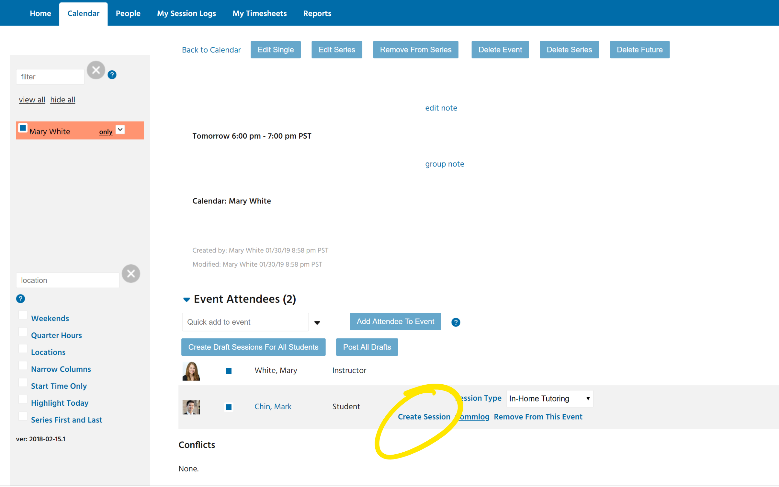

1. Complete the required fields: *Session Type, Subject, Attendance, Location*, and
2. Enter Ratings for: Engagement, Preparation, Progress and Homework (if assigned)
3. Complete the Student Note field as well as Client and Admin Note fields as may be required.
4. Press, SAVE
5. Press, POST SESSION

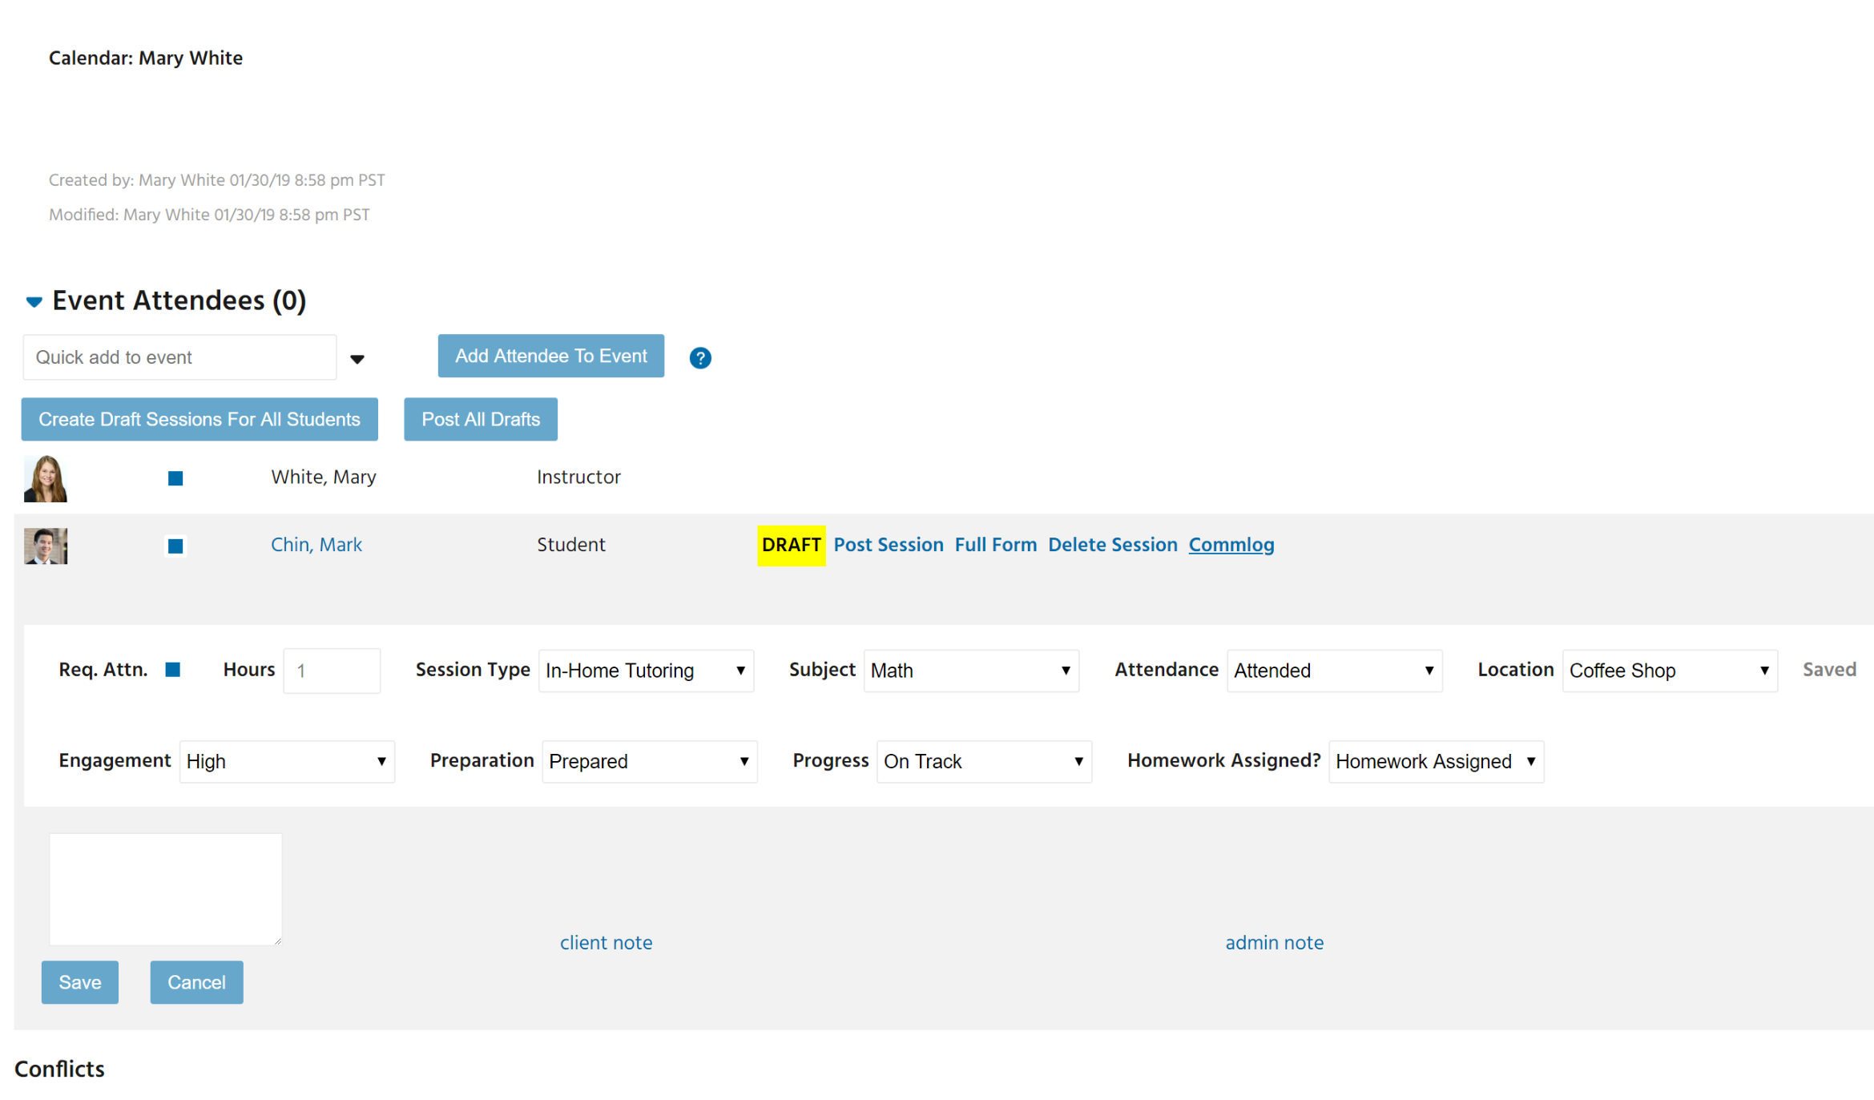

Writing a Session Report, Key Points

Most of your Session Logs will only require a note written in the Student Note field. In addition to the student, parents and administrators will also see this note.

If you need to write something to the parent that you don’t want to include in the student note, use the Client Note field.

Lastly, use the Admin Note when you need to communicate something to administrators. NOTE: Write all notes in a way that you would not feel bad about everyone seeing.

Remember to:

1) Be concise about what you worked on.

2 ) Report if the student is on or off path towards their goals. If off path, report how you are addressing this with the student, be specific about the solution you and your student have decided upon.

3) Be specific about any action parents may need to take to support their child.

4) Make sure to ask for help from an administrator if needed.

Session Logs which are Not Posted

If tutor has not completed a Session Log for the scheduled “Event”,

1. A prompt to complete the report / log will be listed on tutor’s HOME TAB under SESSIONS NEEDING REPORTS.
2. Past due session logs are highlighted in red.
3. You can complete the Session Logs from here as well as from the Calendar.

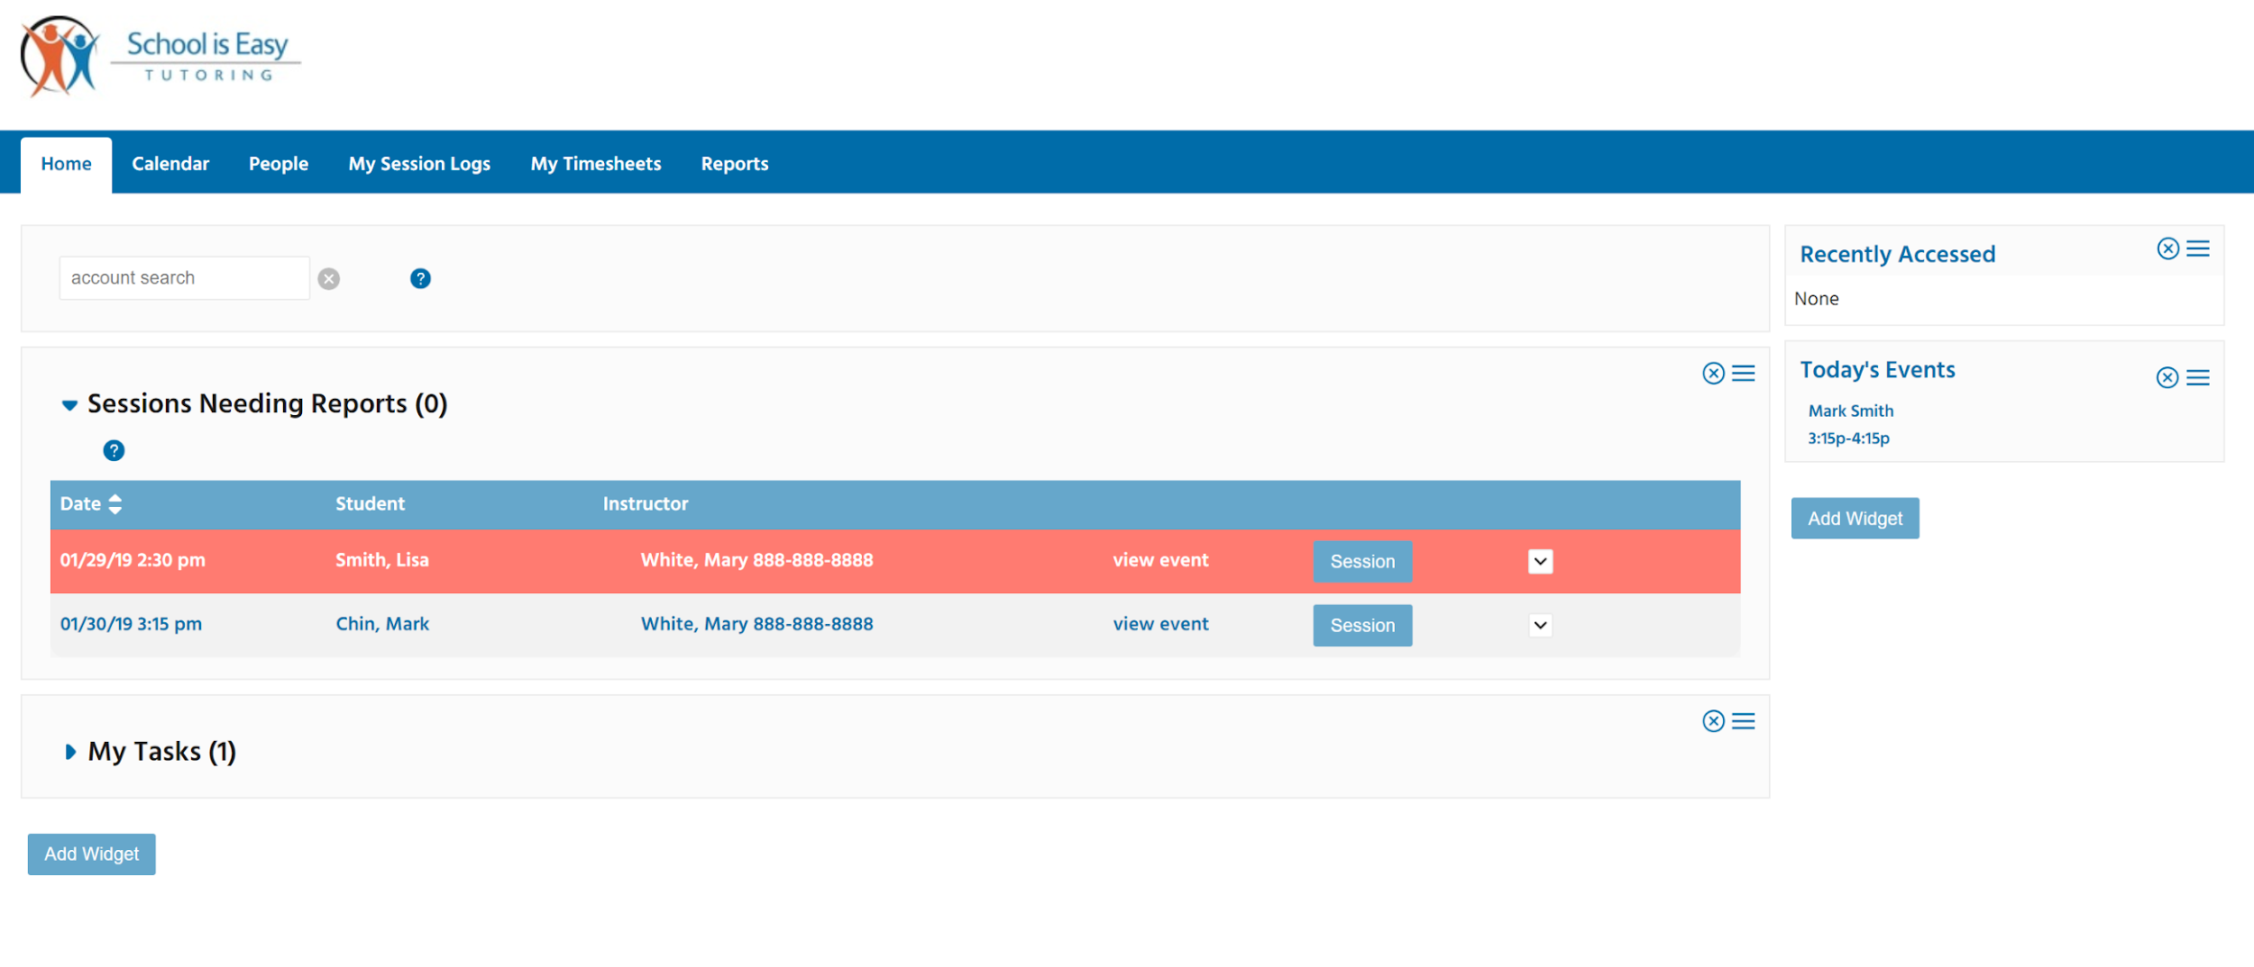

1. While the form looks different, the Session Log fields are the same when creating a Session Log from the Calendar or from the Sessions Needing Reports list. (see image on next page)

**Note: Timesheets are automatically created in Opus when you post a Session Log.   
Timesheets will be approved when the Session Log is approved by an administrator.**

**For further information about writing Session Logs, refer to the document:**

**“Tutor Orientation, Part II *Writing a Session Log, Best Practices”*.**

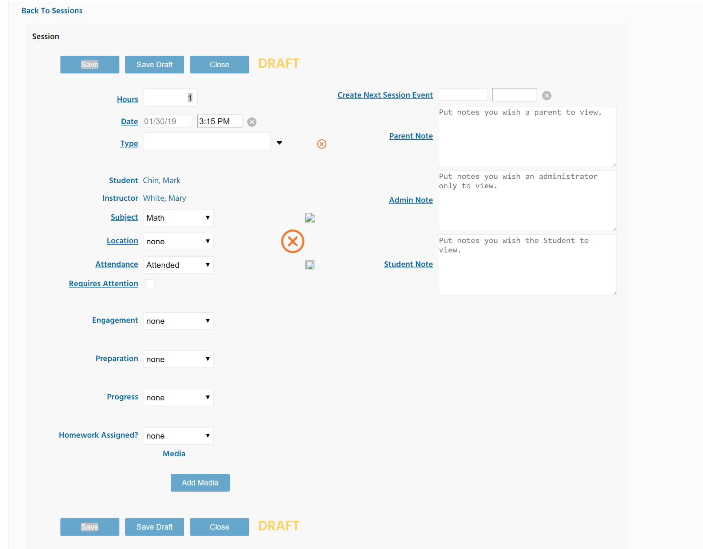

# In addition to the terms outlined in your signed Tutor Agreement,

## You, the tutor will:

1. Attend a School is Easy orientation before working with any clients.
2. Always be on time, dress neatly, be clean and have fresh breath.
3. Tutor in an open space, visible to the rest of the family, or in a public location.
4. Be prepared for each lesson. Provide appropriate materials according to the student's level and learning style.
5. Review previous lesson(s) and assess the student's progress - communicating regularly with SIE Director and Admin about progress.
6. Contact School is Easy immediately if rescheduling is required.
7. Keep School is Easy up to date on your availability.

## Contacting the classroom teacher

* It is sometimes a good idea to be in touch with the classroom teacher and during the consultation, the Director will have mentioned this. If however, the parent brings it up with you, please contact School is Easy admin to follow up.
* If the parent and School is Easy admin request that the tutor meet in person with the classroom teacher then the tutor will be paid their hourly tutoring rate.

# Tutoring Materials

Notify your School is Easy Director if you want to suggest that the parent purchase supplemental materials. Call the office directly or add it into the Admin note of a Session Log, marking the Session Log as “Requires Attention.”

# Tutor's Information

Please keep School is Easy informed of address changes, name changes, subjects you are willing to teach and areas of our region, in which you are willing and able to travel and provide tutoring.

# School is Easy <your location> will:

* Make every effort to offer tutoring sessions in the proximity convenient to the tutor.
* Work as a team and provide support for the tutor should problems arise.
* Promote open and helpful communication between student, parent, tutor, school and SIE admin staff.

# Most Frequently Asked Questions

## How much tutoring work will I get? Or What is the average number of hours that a tutor works per week?

Answer: We can't answer this question. The demand is always changing. You will be put into the database and you will be contacted when we receive a registration for subjects in your area.

**What is the cancellation policy?**

Answer: In the event the Client wishes to reschedule or cancel a tutoring session, the Client shall give SIE at least 24 hours notice. In the event that the Client does not provide at least 24 hours notice of the need to cancel or reschedule a session, the Tutor will be paid a cancellation fee of 1/2 hour of their tutoring rate. If the Client does not provide 3 hours notice of cancellation the Tutor will receive payment for one hour at their tutoring rate.

In order to be paid, the Tutor must create a standard *session log* with the appropriate attendance selected, Late Cancel (24hr) or Absent if a student was a no show or cancelled the within 3hrs of the scheduled session. Be sure to document when the parent notified the office or you of the schedule change, and what was said.

-END-