

**Tutor Orientation, Part I**

**Tutor Handbook - Working in Opus 2.0**

# 

# 

# Welcome to School is Easy

Outlined below are the key elements which make up our Brand - what we are known for. Please take the time to not only read through each element, but embrace and take ownership of them. Our Brand comes alive through us and through You; in conversation, attitude and behaviours – essentially, through every interaction we have with our students, parents and schools.

We are excited you have joined our team. Please take the time to enjoy the process. Tutoring is meant to be educational *and* FUN!

## Our *Vison* for School is Easy

Empowering students with the confidence and skills to succeed in their personal and career goals. Helping students to become the HERO of their own stories and change the trajectory of their lives.

## Our *Mission* outlines what we focus on as we work toward fulfilling our vision.

School is Easy is a full-service, relationship-based tutoring service, providing personalized, in-home, one-to-one tutoring support, to families who may be struggling with their children’s education.

## Unique Selling Proposition (USP)

In any business, competition is fierce. What is it then that sets us apart from the average provider?

Answer: Successful businesses identify and define what makes them “better” than their competitors and what differentiates them. At School is Easy we promote the following four elements in our communities, through our marketing and our amazing team of people.

1. **At School is Easy, we personalize learning**

We provide tailored, in home, one-to-one tutoring. Unlike learning centres, we do not operate from a set curriculum – how could we? Every student is unique, with individual needs, goals, personalities and learning styles! Rather, we personalize our courses of tutoring based purely on the individual learner, ensuring each learning plan we create is unique to them and each session report we deliver is focused only on that student/session, rather than a group.

1. **At School is Easy, we help our students achieve their goals**

Learning goals are unique and every student’s educational journey is different. Some students are aiming to get into university or to earn a scholarship. Others may need targeted support with a specific subject, assistance with learning loss, help with executive functioning skills, or a program of exam prep. It’s hard to know what the issue is on the end of a laptop or phone, so at School is Easy we use our unique *Consultation* process, to learn exactly what the student’s challenges are, what parents are worried about, what the family’s goals and aspirations are, and ultimately, how to get them to where they need to be.

1. **At School is Easy, we work together to make a difference**

We are not the solution – we are PART of the solution. We work together to make a difference. Communication flows between School is Easy team, the Parent(s), the Student, and even the Student’s school teacher(s), to ensure we have the right plan in place to achieve the goals we have set out. School is Easy constantly monitors that progress, reports on it after *every* tutoring session and then modifies the plan if necessary.

1. **At School is Easy, we embrace diversity**

Whether it's background diversity, ability, home situation, learning style, or personality, all children are different: they behave differently and learn differently. At School is Easy, our doors are open to all children who need support with their education.

**OPUS**

At School is Easy we work as a team and our OPUS business management system allows us to do that. OPUS provides the transparency and visibility we need, to best support our students and families.

As a School is Easy tutor, you will be responsible for a few administrative tasks. In order to do that, you will have your very own OPUS tutor account!

The following are key OPUS tutor tasks and responsibilities:

## Activating your OPUS tutor account

## Responding to ‘Tutor Match’ requests

## Completing the assigned ‘Student Task’

## Reviewing the student ‘Work Order’ before engaging with the client

## Working with SIE Director/Admin, to ensure your tutoring sessions are scheduled in your ‘OPUS Calendar’ and, up to date

## Writing and submitting ‘Session Reports’ in OPUS after EVERY student tutoring session

Each of these tasks/responsibilities are outlined in the following pages.

Note: Keep a look out for the heading “***Working in Opus:***” These sections will provide you with step-by-step instructions and/or screenshots, for completing a given task in your OPUS tutor account.

Note: Depending on how your SIE business operates, not all tasks listed below will need completing. Keep a look out for highlighted yellow text, which provides pertinent information on a task.

## Activating Your OPUS Tutor Account

When you onboard as a tutor with School is Easy, the first task you will need to complete is activating your OPUS tutor account. Follow the steps below to do this.

**Working in Opus:**

# Activating your OPUS tutor account

When you sign up to become a tutor with School is Easy, you will be invited to set up your account for our management system; **OPUS**: <https://opus2.schooliseasy.com/gd/index>

As a tutor, your OPUS account will allow you to see which students you have been matched with and also allow you to create the tutoring sessions in your OPUS Calendar. This ensures all parties are aware of when tutoring sessions will take place.

1. You will receive an invitation email from School is Easy

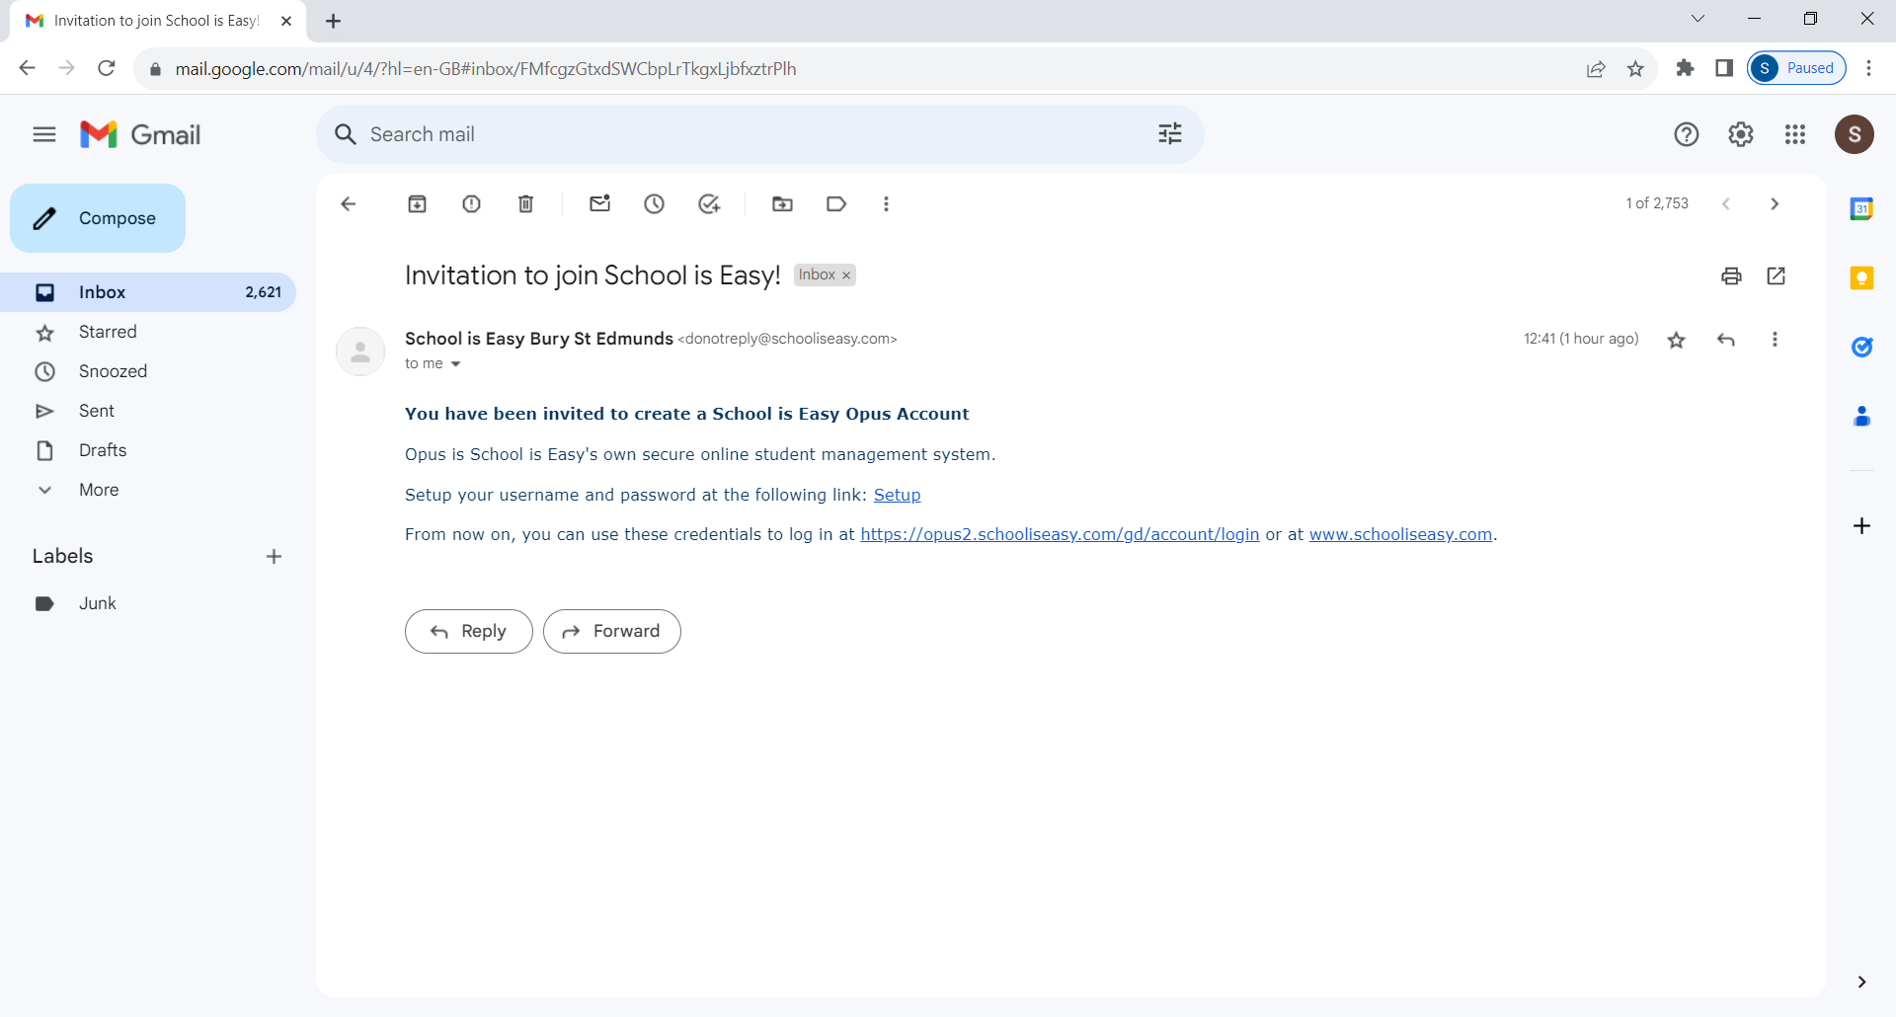

1. Select the **Setup link**
2. You will be taken to the OPUS End User License Agreement. Please read then select **I Accept**

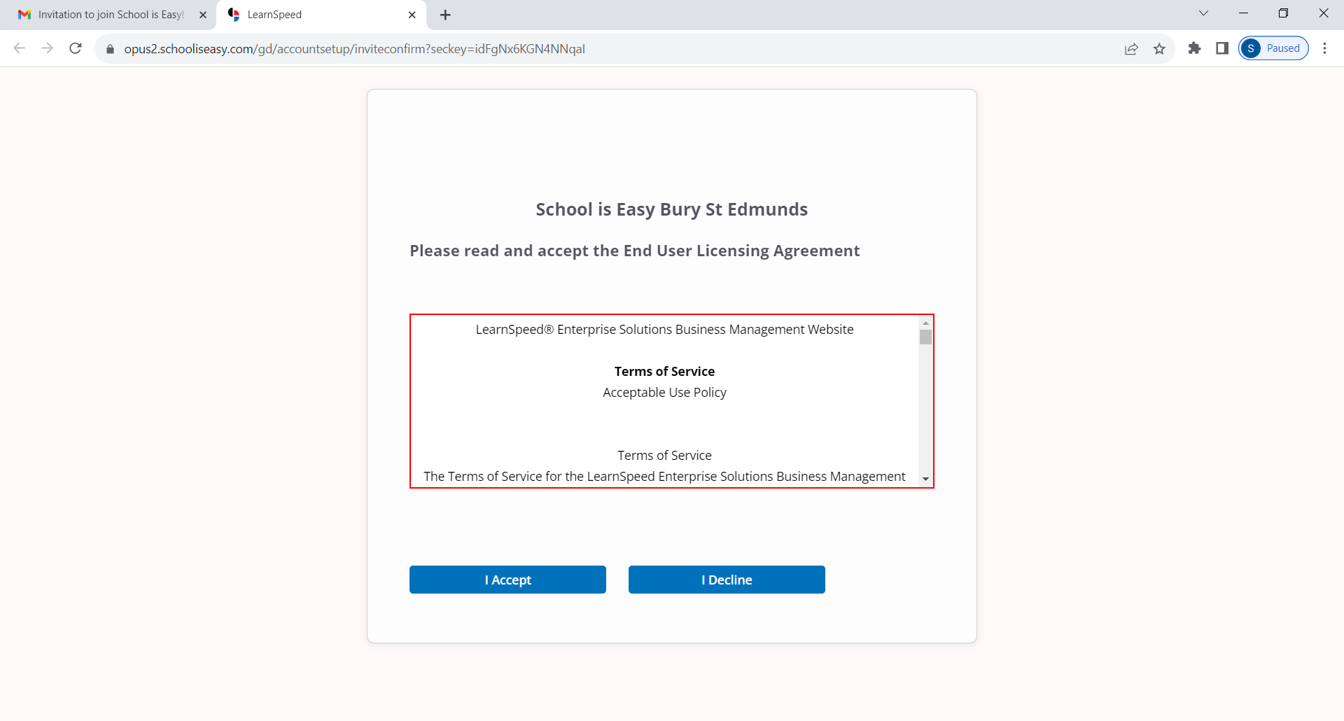

1. Enter a Username and Password (if a username is already in use it will tell you on screen and you will need to create another)
2. Click **Save**

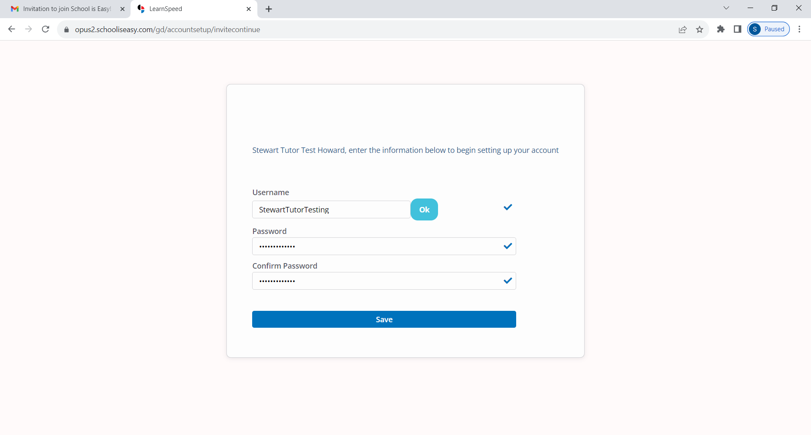

1. The following message will appear that the account has been successfully created.
2. Click **Login**

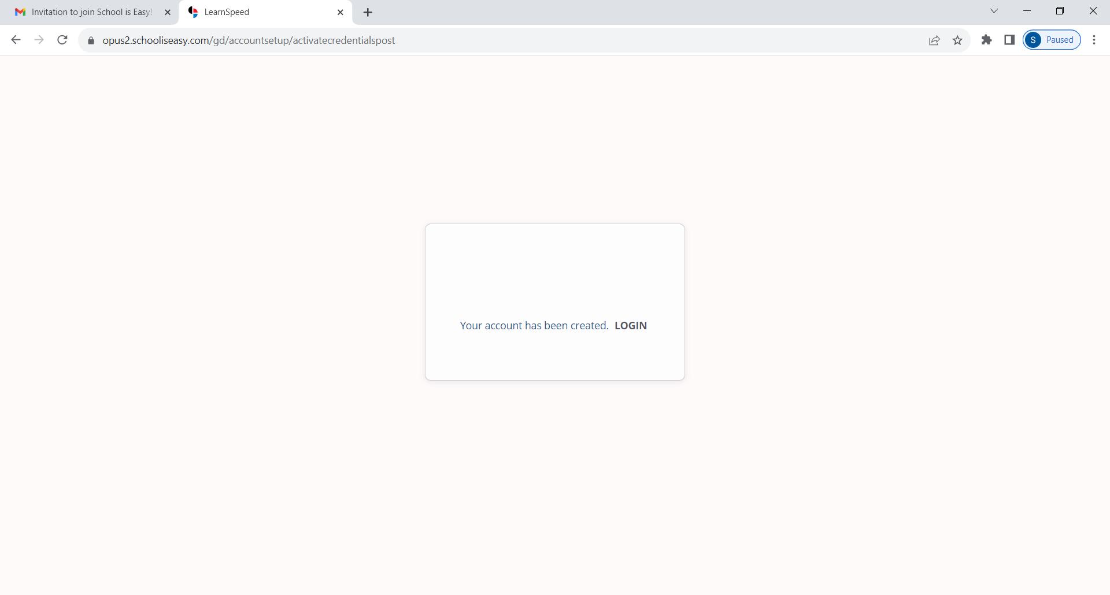

1. You can now enter your newly created Username and Password
2. Click **Login**

(If you forget your Username or Password you can reset them by clicking on the relevant link below (‘Forgot your Username’ and ‘Forgot your Password’)

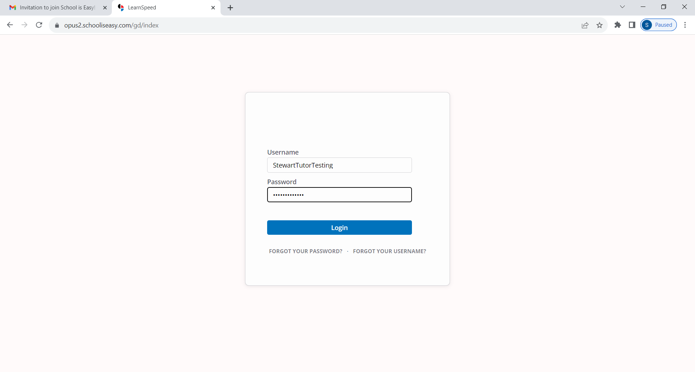

1. You will now be successfully logged into your OPUS tutor account

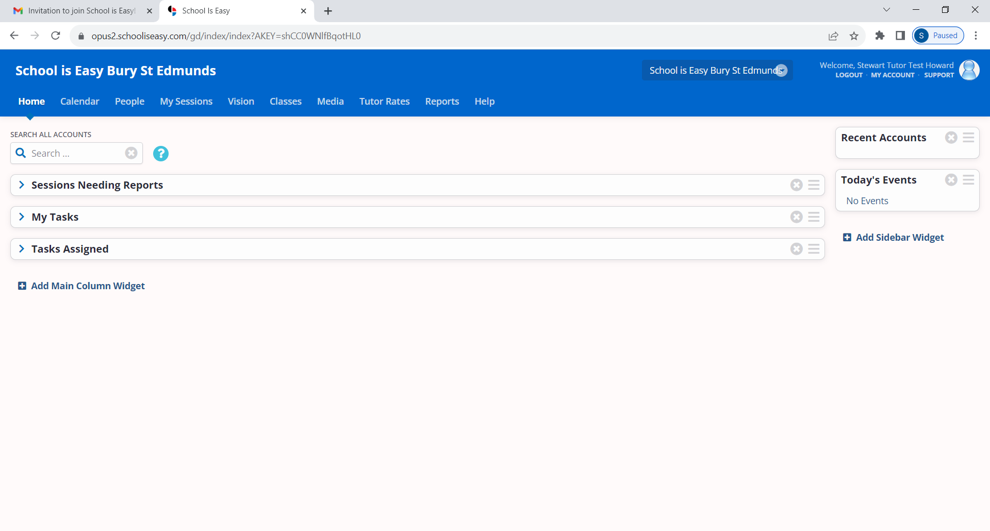

## Responding to ‘Tutor Match’ Requests

When a new student has been enrolled or needs to be matched with a tutor, your School is Easy Director or Admin will either send out a Tutor Match Request by email, or contact you directly. The communication will outline the location, subject, package size, and preferred schedule for the sessions. It is important that you respond immediately, to either accept or reject the match.

As the request may be sent to multiple tutors at a time, a quick response will increase your chances of securing that assignment (match).

Note: This step will only be necessary if the SIE Director/Admin has sent you a tutor match request through OPUS. This tends to happen in larger SIE businesses where tutoring jobs are sent out to multiple tutors at once, to save time. Often, tutor matching is conducted outside of OPUS.

**Working in Opus:**

* When you log into Opus, your HOME screen will display the image below
* This screen shows that one ‘Task’ requires your attention.

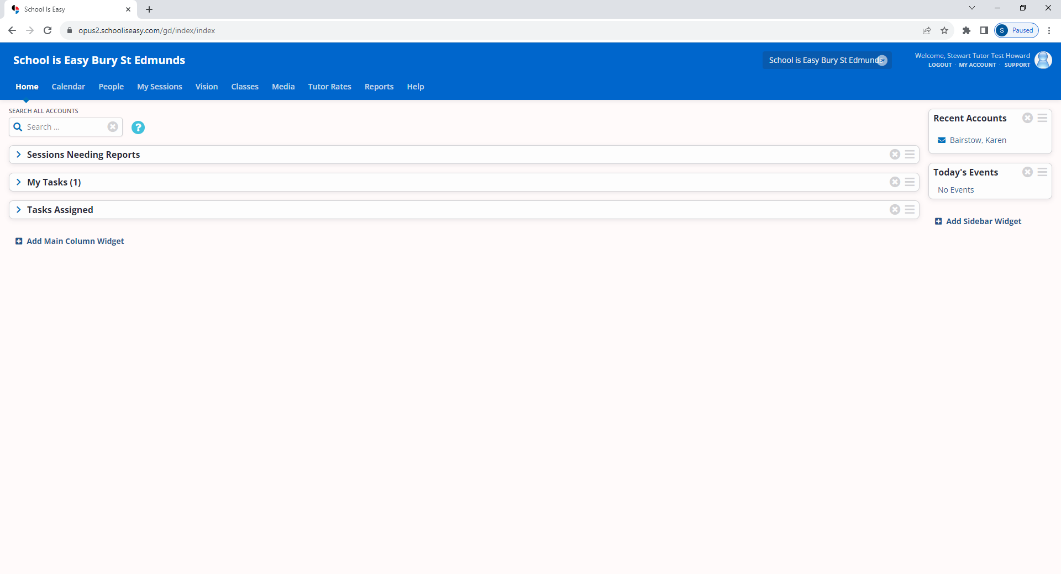

## Completing the Assigned ‘Student Task’

When you accept a match, an Opus Task will be created and an email notification will be sent to you that the task has been assigned to you. Please complete the task within 24hours of receipt.

Task: The task will ask you to contact the parent, introduce yourself and confirm date/time of first session

Note: As with step 2 above, this step will only be necessary if the SIE Director/Admin sent you a tutor match request through OPUS and you therefore have a task assigned to you. This tends to happen in larger SIE businesses where tutoring jobs are sent out to multiple tutors at once, to save time. Often, tutor matching is conducted outside of OPUS and therefore no task will be created in OPUS.

**Working in Opus:**

The Task will appear on your Opus Home tab under the ‘My Tasks’ section.

1. *Expand the section by clicking on the blue triangle to the left of My Tasks.*
2. *Place your cursor over the information “i” icon to the left to view the full task. Click on the “i” icon if you want to keep the window open to adjust the size.*

Prior to completing the Task, review the ‘*Work Order*’. (Refer to section 4 *Reviewing the student ‘Work Order’ before engaging with the client*’ for more information on ‘Work Order’)

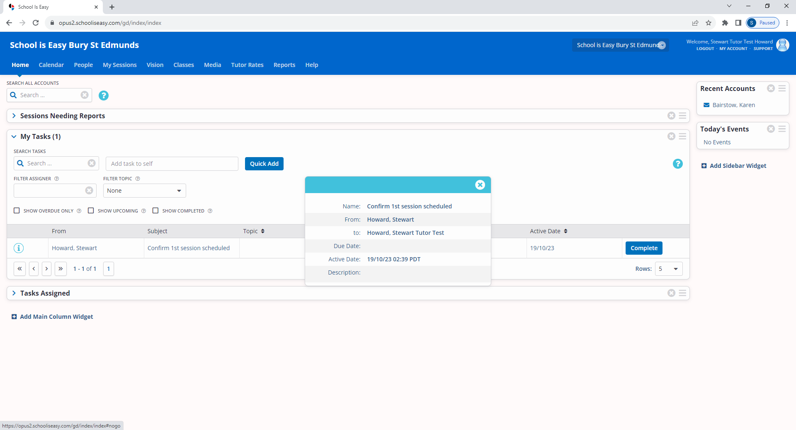

Once you have read the ‘Work Order’ and cleared up any questions you may have with the SIE Director/Admin, proceed to completing the ‘Task’

1. *When you have completed the task, click on the Complete button (previous image, right side of window)*

## Reviewing the student ‘Work Order’ before engaging with the client

The student *Work Order* is information that has been gathered about the student, during the consultation process. This information will be useful for the tutor in creating a learning plan before tutoring begins.

**Working in Opus:**

1. *Go to the student’s record under the PEOPLE tab or use ‘Account Search’ to find a student.*
2. *Under the student account, find the WORK ORDER tab and put your cursor over the information “i” to view the WORK ORDER.*

The Work Order can be saved or printed out as a pdf by clicking on the triangle to the right side of the Work Order in the list. **It is essential that you read the Work Order before contacting the parent.**

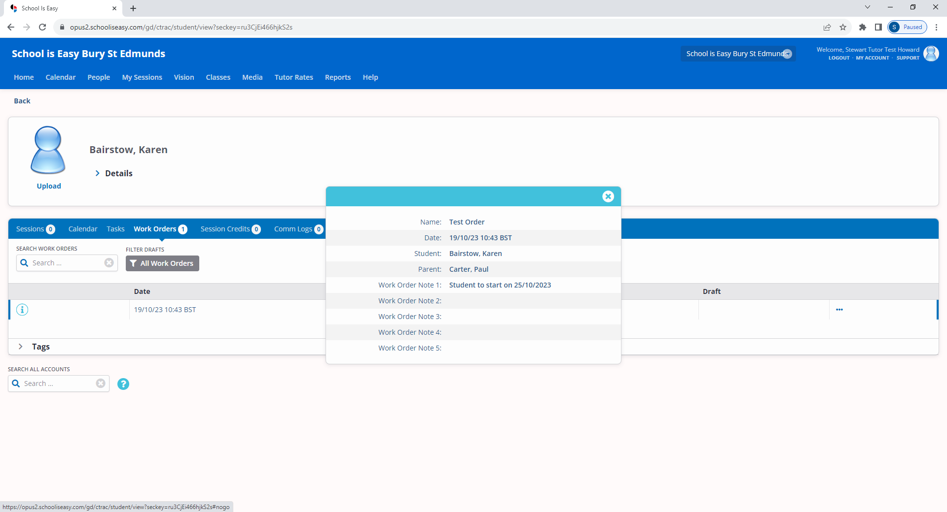

## Working with SIE Director/Admin, to ensure your tutoring sessions are scheduled in your ‘OPUS Calendar’ and, up to date

Once your tutoring schedule has been confirmed by the SIE Director, all scheduled tutoring sessions must be entered into your calendar in OPUS. This ensures that all parties are aware when sessions are due to take place and that everyone attends on the correct day/time.

**Note: SIE Director/Admin usually enters the initial tutoring schedule into your calendar. However, occasionally you may be asked to do this. Similarly, if the client requests a change to the agreed schedule, tutors are required to inform SIE Director and may be required to update their calendar.**

Diarizing your sessions in OPUS, also allows you to create/submit your **Session Reports** which is a critical part of your role as a School is Easy tutor. (see section 6)

**Working in Opus:**

# Scheduling/Posting a Tutoring Session

## To schedule tutoring sessions, follow these steps:

1. Navigate to your **Calendar**

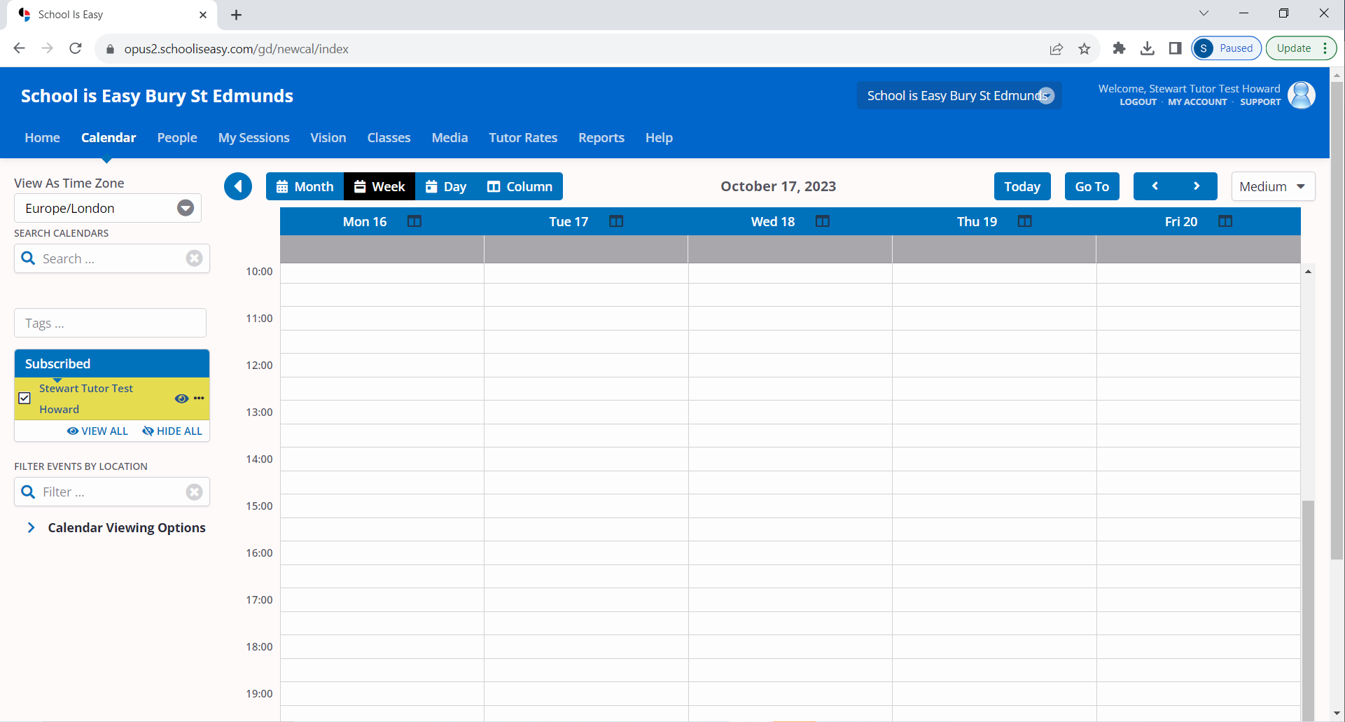

1. Select the correct day and time for the session by double clicking in the relevant space
2. The following page will be displayed

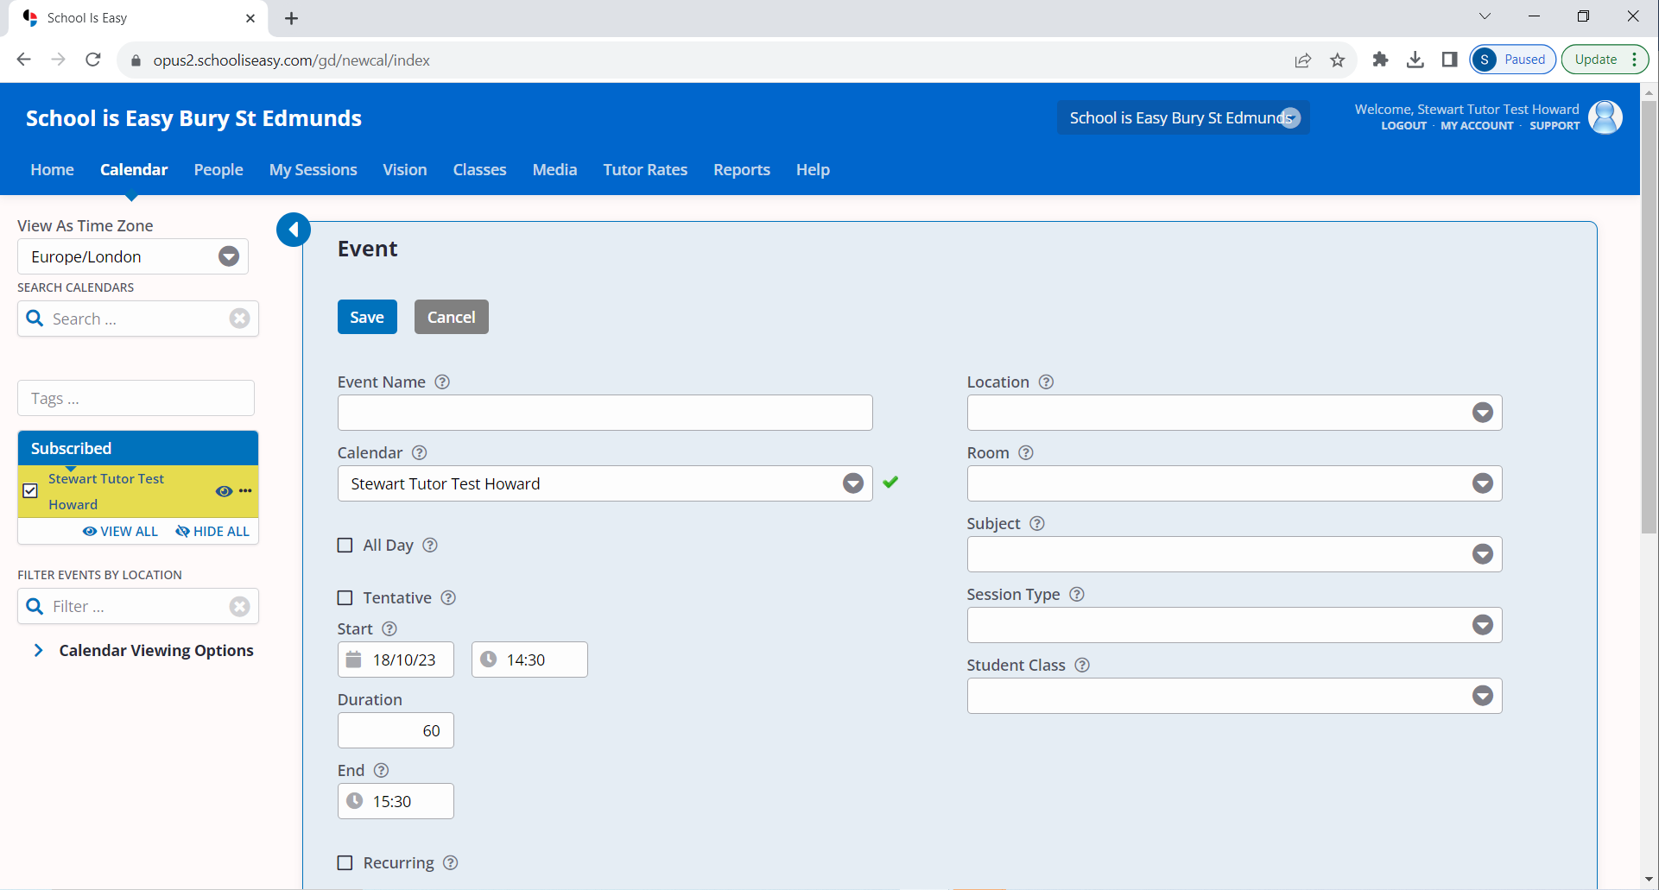

1. You will need to enter the following information:
   1. **Event Name** – Name of the student
   2. **Start Date**
   3. **Duration**
   4. **Recurring** – Sessions will recur on the same day/time each week unless instructed otherwise by your SIE Director/Admin
   5. **Add Attendees** – Click in the ‘Attendees’ field and type in the student’s name

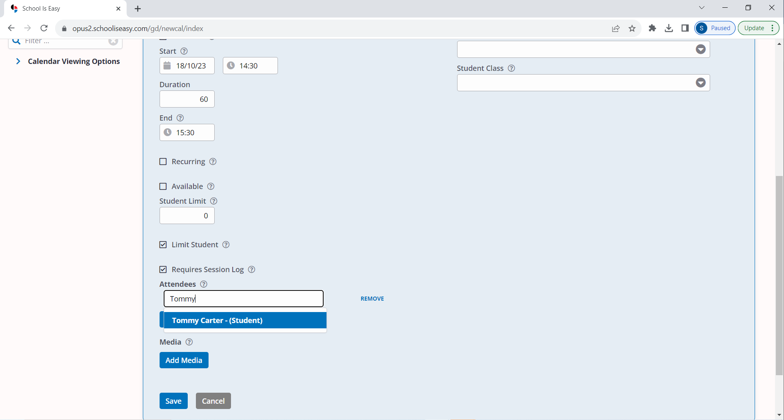

* + 1. Click **Add Attendee**

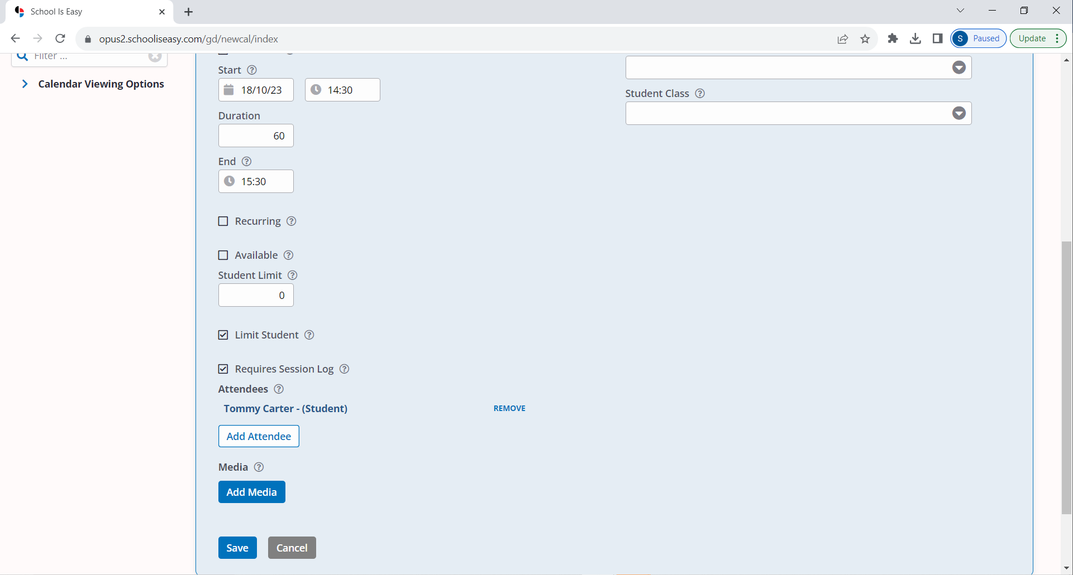

* 1. **Location**
  2. **Subject**
  3. **Session Type** – For the student

1. Click **Save**

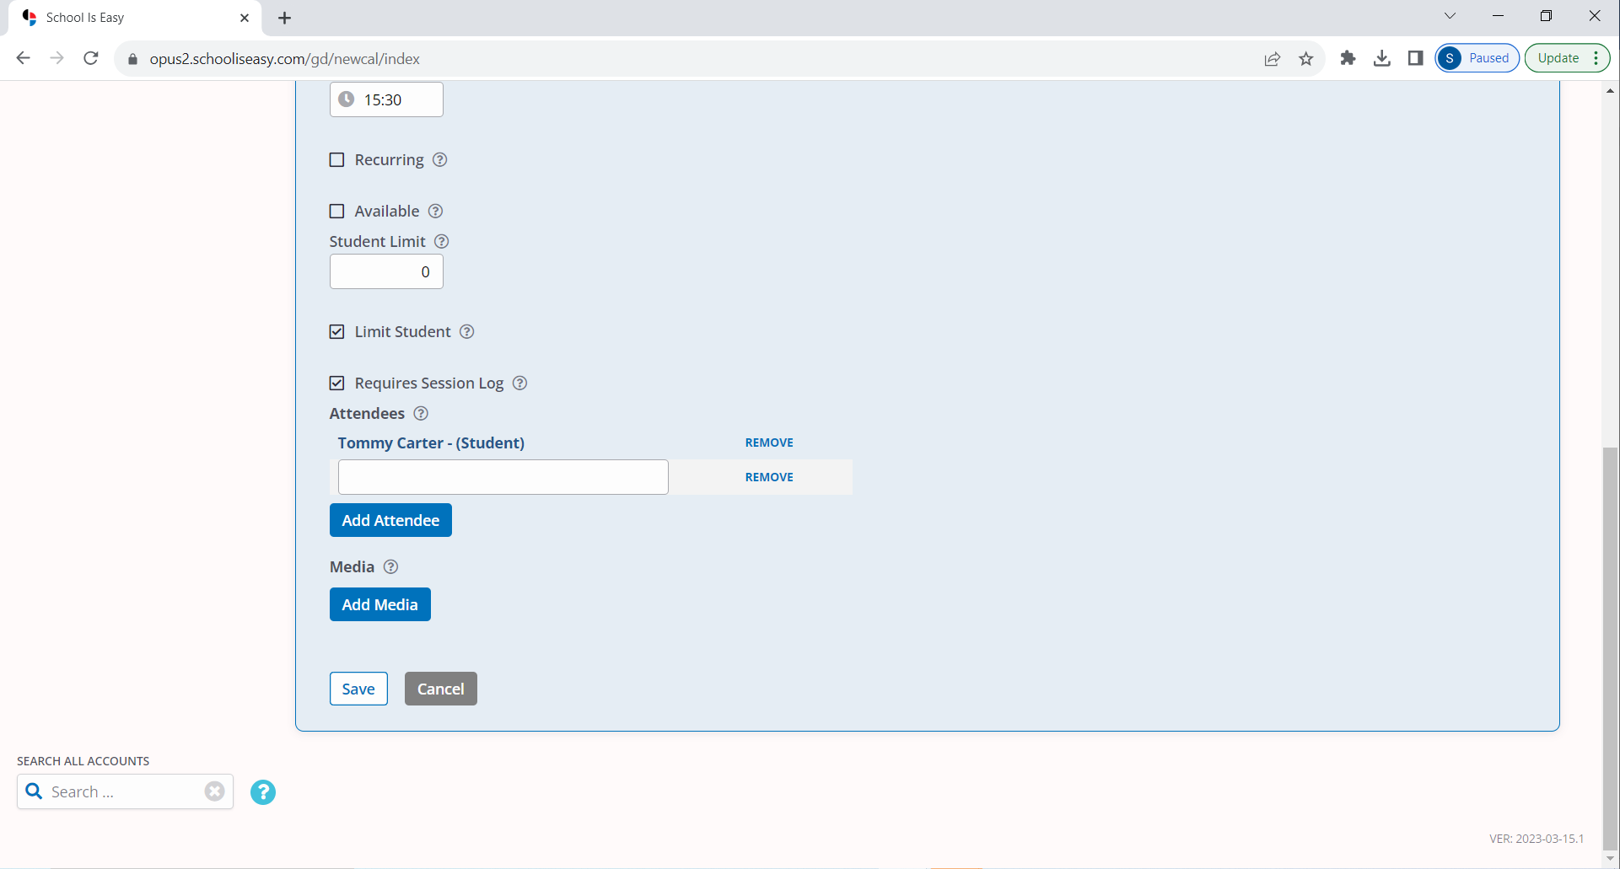

1. The Session is now added to the calendar – check all sessions have populated correctly

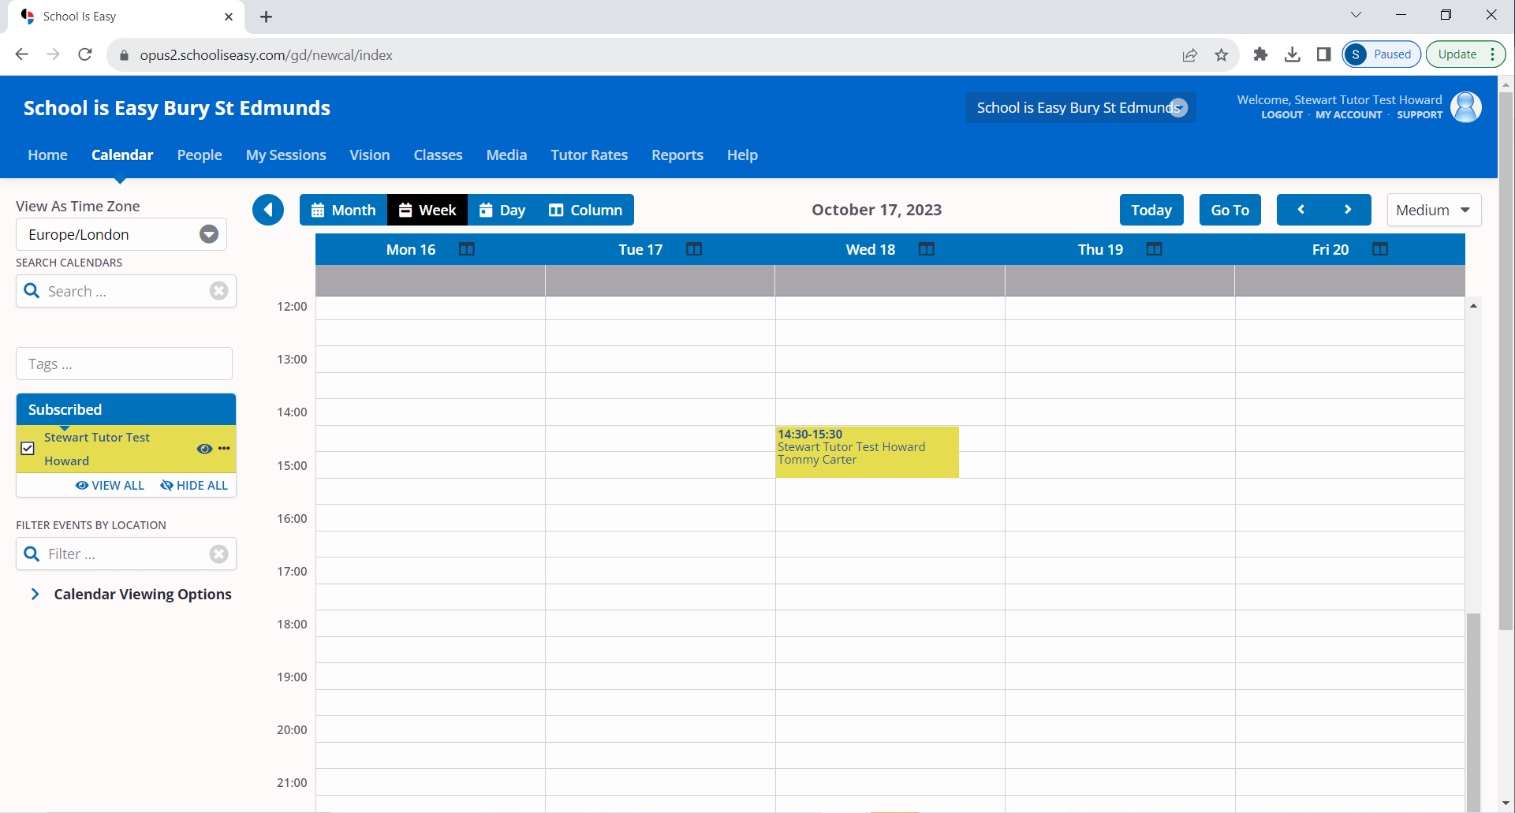

*If the session is a *Vision* session, then please refer to the Vision guide on how to set these up.

## Writing and submitting ‘Session Reports’ in OPUS after EVERY student tutoring session

**SESSION REPORTS** are an essential part of your role as a School is Easy tutor and MUST be submitted in OPUS on the same day as the tutoring session takes place.

At School is Easy, communication flows between the School is Easy team, the parent, and (where permission has been given) the student and the school teacher(s). This communication is maintained in the form of a **Session Report**, which is a written account of the tutoring session. Session reports ensure parents have complete visibility (and therefore peace of mind) of student progress. They build a picture of what a student has covered, what they did well/struggled with, and what they need to focus on moving forward. The information in your session report also serves as a written record for tutors and the SIE team, enabling us to modify student learning plans, so our students get the most out of their tutoring.

Session Reports are created by the tutor in OPUS, reviewed by the SIE Director and then emailed to the parent. Depending on the arrangements made with the parent(s), Session Reports can also be emailed to the student and even the student’s class teacher(s) if requested.

**Working in Opus:**

# Creating Session Reports

After the tutoring session, follow these steps:

1. Double click on the relevant tutoring session in your OPUS calendar
2. Click on **Add Draft Session**

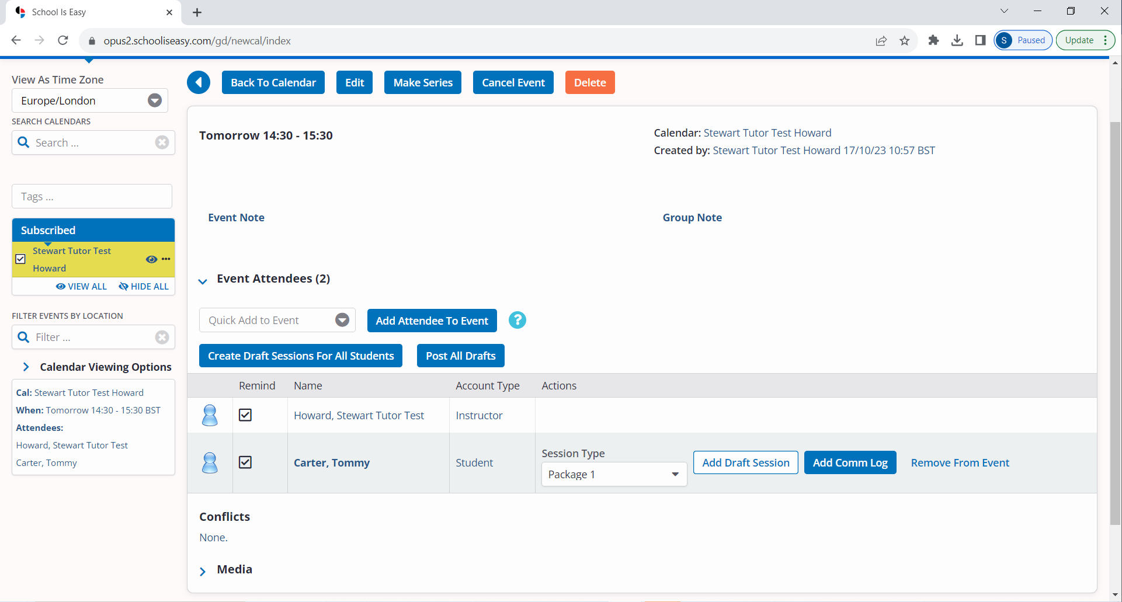

1. Ensure all details are correct, then add your ***Session Report*** in the ‘Client Note’ box (see guide – ‘*Tutor Orientation Pt 2 - Writing a Session Report*’)

Note: You may also wish to add a note for the student and/or SIE Admin.

* **Client Note** (this is your ***Session Report***) will go to Client/Parent, SIE Admin
* **Admin Note** will only go to your School is Easy Admin
* **Student Note** will go to Student, Client/Parent, SIE Admin

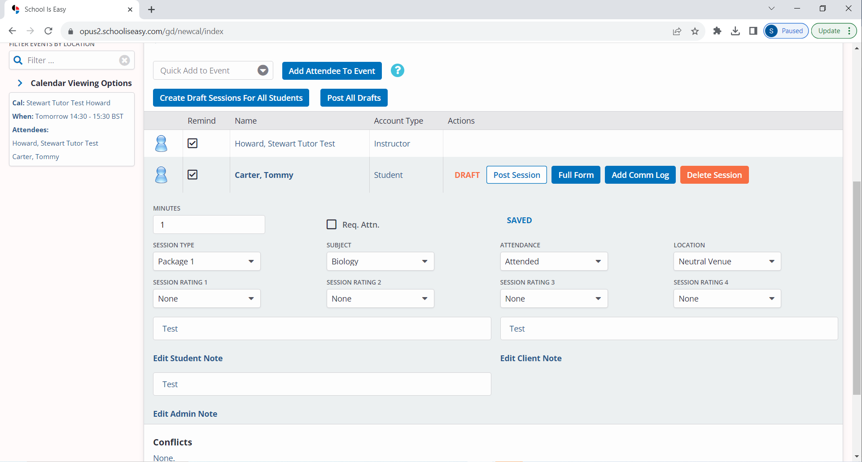

1. Once you are happy with the content, click **Post Session**



1. The Session has now been submitted to your School is Easy admin for approval

Writing a Session Report, Key Points:

* Your Session Reports must be written in the *Client Note* field. They should be of sufficient length to include all required information.
* If you need to write something to the student directly, (e.g. *Remember to read chapter 17 before next week’s session*) use the *Student Note* field.
* Use the *Admin Note* field when you need to communicate something to SIE Admin (e.g. *the parents have requested a pause in tutoring over Christmas*)
* For detailed information on writing sessions reports, see part two of this guide –

**‘*Tutor Orientation Pt 2 - Writing a Session Report*’**

Note: Write all session notes in a way that you would feel comfortable with everyone reading.

**Session Reports which have NOT been posted**

If a tutor has not completed a Session Report for a scheduled “Event”:

1. A prompt to complete the report will be listed on the tutor’s HOME tab under *SESSIONS NEEDING REPORTS*
2. Past due session reports are highlighted in red
3. You can complete the Session Reports from here, as well as from the Calendar

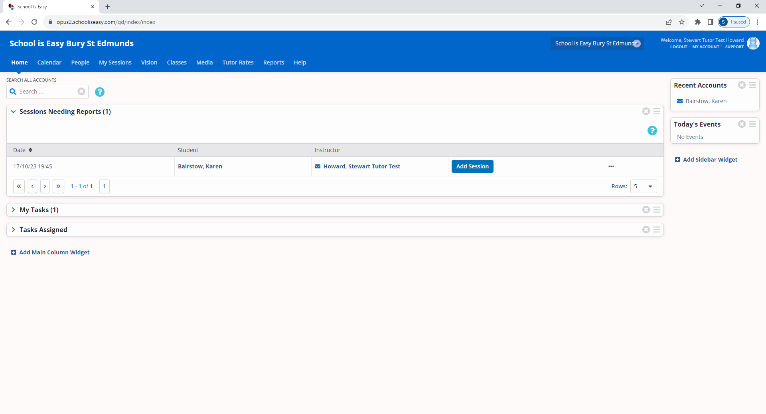

1. While the form looks different, the Session Log fields are the same, (Client Note, Admin Note, Student Note), whether creating a Session Report from the Calendar or from the Sessions Needing Reports list. (see image below)

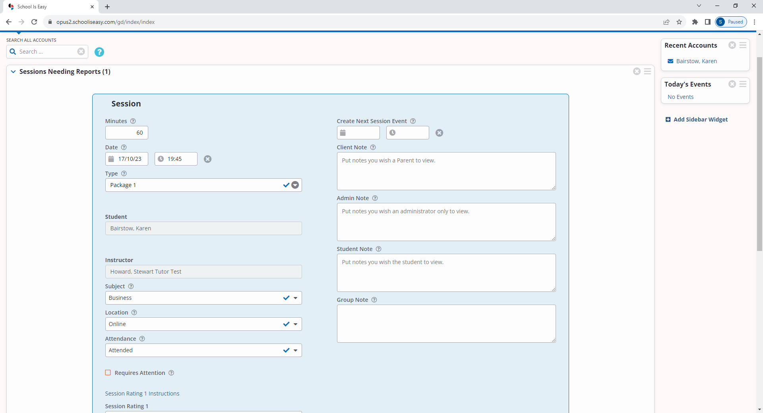

**Click Save once all information has been added.**

**In addition to the terms outlined in your signed Tutor Agreement**

## Tutors are required to:

1. Attend a School is Easy orientation before working with any clients.
2. Enter all tutoring sessions into your OPUS calendar BEFORE sessions take place.
3. Always be on time and be well-presented (dress neatly, be clean and have fresh breath).
4. Tutor in an open space, visible to the rest of the family, or in a public location.
5. Be prepared for each lesson. Provide appropriate materials according to the student's level and learning style.
6. Carry sufficient liability insurance.
7. Review previous lesson(s) and monitor/assess the student's progress ongoing.
8. Communicate regularly and openly with SIE Director and/or Admin.
9. Contact School is Easy immediately if rescheduling is required.
10. Keep School is Easy up to date on your availability.

## Contacting/Meeting the Classroom Teacher

* It is often valuable to be in touch with a student’s classroom teacher and during the client consultation, the SIE Director will have discussed this with the parent. If, however, the parent brings it up with you directly, please relay this to the School is Easy Director/Admin ASAP.
* If the parent and School is Easy request that the tutor meet in person with the student’s teacher(s), then the tutor will be paid their normal tutoring rate.

# Tutoring Materials

Notify your School is Easy Director/Admin if you want to suggest that the parent purchase supplemental materials. Call the office directly or add it into the Admin note field when completing your Session Report, marking the note as “Requires Attention”.

# Tutor's Information

Please keep School is Easy informed of address changes, name changes, contact details changes, subjects you are willing to teach, and areas in which you are willing/able to travel to provide tutoring.

# School is Easy will:

* Make reasonable efforts to offer tutoring sessions in locations convenient to the tutor.
* Work as a team and provide support for the tutor should problems arise.
* Promote open and helpful communication between student, parent, tutor, school and SIE admin staff.

# Frequently Asked Questions

## How much tutoring work will I get?

**Answer:** This is hard to determine because the demand for tutoring is always changing. Once onboarded as a tutor, you will become part of the School is Easy tutoring team and be added to the database in OPUS. You will then be contacted whenever we receive work for subjects in your area.

**What is the cancellation policy?**

**Answer:** In the event the Client wishes to reschedule or cancel a tutoring session, the Client shall give SIE at least 24 hours’ notice. In the event that the Client does not provide at least 24 hours’ notice, the Tutor will be paid a cancellation fee of 1/2 a session of their tutoring rate. If the Client does not provide 3 hours’ notice of cancellation, the Tutor will receive payment for their full session at their tutoring rate. Mark ‘Late Cancel’ (24hr) or ‘Absent’ if a student was a no show, or cancelled the within 3 hours of the scheduled session. Be sure to document when the parent notified the office or you of the schedule change, and what was said.

**How do I get paid?**

**Answer:** In order to be paid, the Tutor must create and submit a valid *Session Seport* (with the appropriate level of information and approved by the SIE Director) for every session in a month. Payment will be made into the tutor’s designated bank account on a monthly basis.

**Which area(s) will I be required to cover?**

**Answer:** School is Easy requires tutors to work within a designated radius of where they are based. This area is specified by the local SIE Director and will vary from center to center. If tutors are asked to work outside of the specified area, then a premium for travel expenses/time may be negotiated with the SIE location Director.

**What does my rate of pay include?**

**Answer:** The per session rate you are paid, is an all-inclusive rate. It includes any extra costs that may be incurred and/or time that may be spent outside of scheduled tutoring sessions, such as travel expenses, lesson planning time, session reporting, or materials you may choose to use in your tutoring sessions. There will be no additional ‘pro-rata’ payments made for time spent outside of scheduled tutoring sessions.

-END-